**Technical Response**

**Submitted By:**

Stealth Solutions, Inc.

**SBA Certified 8(a) Program Participant**

**SAM UEI: RCMZNAHAZ7D9**

**GSA MAS Contract: 47QTCA22D0053**

46191 Westlake Dr. #112

Sterling, VA 20165

Rahul Sundrani

[Rahul.Sundrani@Stealth-US.com](mailto:Rahul.Sundrani@Stealth-US.com)

571-230-5642

**Stealth Solutions, Inc.**

**Response**

**to**

**Export Import Bank of the United States (EXIM)**

**Salesforce Licenses and CRM Services**

**SOLICITATION NUMBER: 83310124Q0100**

**August 1, 2024**

**Submitted By:**

Stealth Solutions, Inc.

**SBA Certified 8(a) Program Participant**

**SAM UEI: RCMZNAHAZ7D9**

**GSA MAS Contract: 47QTCA22D0053**

46191 Westlake Dr. #112

Sterling, VA 20165

Rahul Sundrani

[Rahul.Sundrani@Stealth-US.com](mailto:Rahul.Sundrani@Stealth-US.com)

571-230-5642

Table of Contents

SF1449 FORM 1

SF30 Amendment Form 2

Executive Summary 1

1 Performance Work Statement (PWS) 4

1.1 Purpose 4

1.1.1 EXIM Salesforce Background 4

1.1.2 How is EXIM staff currently using Salesforce CRM 6

1.1.3 Objectives 7

1.1.4 Scope of Work (Overarching Technical Objectives – SOO Section 4) 7

2 Quality Assurance Surveillance Plan (QASP) 21

2.1 Methods Used for Identifying and Preventing Defects 22

2.2 Roles and Responsibilities 23

2.3 Performance Requirements Summary (PRS) 24

2.4 Performance Metrics and Reports 24

2.5 Evaluation and Feedback 25

2.6 Continuous Improvement 25

2.7 Conclusion 25

3 Key Personnel Resumes with Commitment Letters 25

4 Staffing/ Transition Plan 25

4.1 Staffing 25

4.1.1 Organization Chart 26

4.2 Transition Plan 29

5 Technical Approach to Successfully Meeting Deliverables 30

5.1 Approach for meeting objectives/focus area 30

5.2 Technical Approach for Scope of Work and the Corresponding Deliverables 35

5.3 Project Management Plan (PMP) 44

5.4 Contract Management Communication 44

5.5 Subcontractor Management 45

5.6 Agile – Scrum Development Software Development Lifecycle 46

Appendices 48

Appendix A–Resumes and Letters of Commitment 48

Janani Ganesan, PMP 49

Nick Rampton 53

Akeem Shane 56

Appendix B–Sample Project Management Plan Table of Contents 59

SF1449 FORM

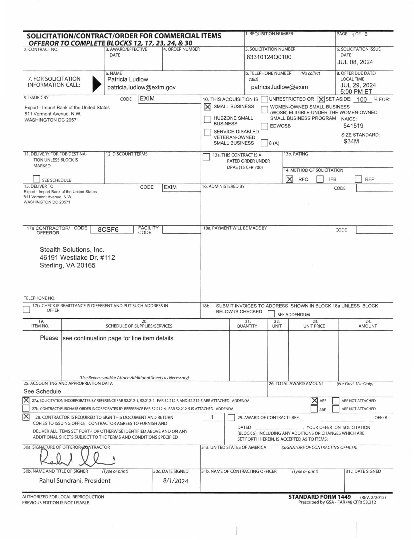

SF30 Amendment Form

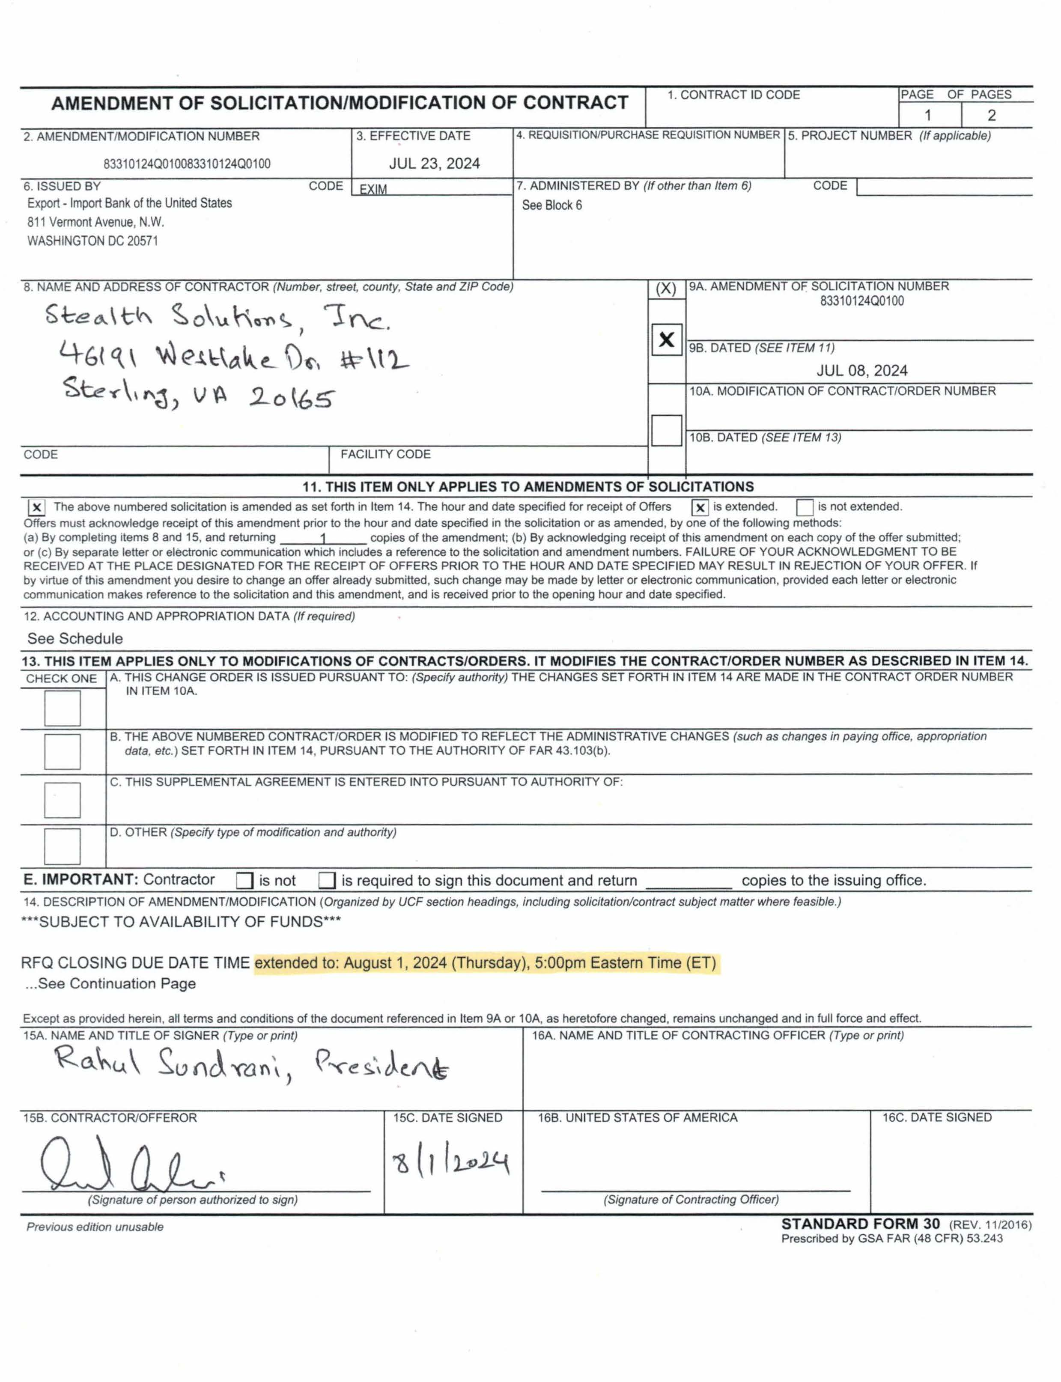

# Executive Summary

Stealth Solutions, Inc. (Stealth) is a Virginia-based SBA-certified 8a small business incorporated in 2014. Stealth is a contract vehicle holder on 8a STARS III and GSA’s Multiple Award Schedule (MAS).

Stealth’s key management team personnel have been involved with and hold certifications at various levels of Salesforce for more than 10 years each. Additionally, Stealth is a consulting partner of Salesforce. As a Salesforce Consulting Partner, Stealth provides our clients with the expertise to configure, customize, and develop customer-specific applications on the Salesforce Platform like Service Cloud Implementation, Customer Relationship Management, Grants Management, Contact Management, Learning Management, Investment Management, and others.

Stealth’s Salesforce team encompasses a mindset to deliver maximum value to clients while transitioning to Salesforce and continued operational support excellence, so that clients realize Salesforce value indefinitely. The Salesforce team was built by hiring the best talent in the market and mentoring the talent to deliver superlative results adhering to the Stealth way.

Stealth has also developed close working relationships with larger long-term successful Federal contractors that bring further depth and reach back into specific technology areas.

From a Salesforce cloud platform-based expertise we proudly introduce our subcontracting partner, REI Systems, to complete our well-rounded ***Team Stealth*** for full-service deliverables and a great backdrop if any unexpected surge requirements are uncovered in the future.

REI Systems, Inc. (REI), is a well-known, well-regarded, Virginia-based, unrestricted government contractor with extensive Salesforce experience. Founded in 1989, REI specializes in providing application modernization, grants management systems and products, government data analytics, and advisory services that help government meet the demands of the 21st century. REI brings a deep bench of resources from its VA office, located at 45335 Vintage Park Plaza, Sterling, VA 20166, with more than 850 current employees. Stealth has worked with REI systems on numerous IT modernization and Salesforce-based projects for the last ten years and has other active partnership bids with REI in the selection process.

REI has been a Salesforce partner since 2004. Over that time, they have completed more than 500 implementations of Salesforce across numerous disparate industries and domains. REI has a long-standing history with Salesforce and understands what it takes to deliver against EXIM’s needs and future vision, as a subcontractor to the project. REI offers Team Stealth access to more than 100 Salesforce-certified staff, who collectively own 10 types of certifications ranging from Salesforce Administrator to Salesforce Developer to Salesforce Application Architect. Further, REI’s experience has produced multiple internal subject matter experts (SME) within REI, in the workflows and business processes of public and private sector use cases such as Business Development, Grants Management, Case Management, Economic Development, Eligibility, Enrollment, and Child Welfare Systems.

Team Stealth Salesforce Projects

Figure 1. Team Stealth Salesforce Experience

Team Stealth has successfully delivered numerous Salesforce projects for both Federal and State agencies. Our expertise includes developing Salesforce Accelerators and several AppExchange products. One of our flagship products, **GovGrants**, is an enterprise-class, fully modular, and highly configurable Grants Management System (GMS) built on the Salesforce platform. GovGrants leverages both grants management and Salesforce best practices, offering innovations in system navigation, UI design, ease of use, and business process automation and optimization. GovGrants is currently utilized by over 20 clients, including the Inter-American Foundation (IAF), Northern Border Regional Commission (NBRC), Library of Congress (LOC), Utah State Board of Education (USBE), California Department of Education (CDE), Los Angeles Homeless Services Authority (LAHSA), Cook County, San Diego Economic Development, and many others.

Another notable product, **GovBD**, is an enterprise-class, fully modular, and highly configurable lead capture system, also developed on the Salesforce platform, and is currently in use by over 40 customers. Furthermore, Team Stealth has provided Salesforce implementation and support for Federal agencies such as USAID and HRSA, among others.

Team Stealth

Team Stealth will deliver to EXIM the following four key areas for a Salesforce based enhancement and support deliverables project:

* Salesforce Consulting Services – One of the biggest IT challenges organizations face today is: Should we move to the cloud? If so, two critical decisions must be made: 1) Which cloud to choose, and 2) Which business applications to move. Team Stealth Salesforce Consulting Services works with clients as their trusted IT Partners in identifying what applications are best suited to migration to the Salesforce platform and lays out a migration and product roadmap for a Salesforce Transition. Team Stealth also works with clients on process enhancements, data migration strategies, and change management challenges as part of the transition.
* Salesforce Implementation Services – As part of the Implementation Services, Team Stealth provides our clients with the expertise to implement Salesforce to deliver maximum value. We provide a team of Salesforce consultants who are certified and experienced in configuration, customization, integration, and data migration.
* AppExchange Product Implementation – The enterprise marketplace available from Salesforce – AppExchange – provides more than 3,000 enterprise applications that can be used by many customers for various business needs and can eliminate a significant custom development effort. Even though AppExchange provides many great applications that can be quickly downloaded and installed, many applications need either configuration or customization to the core product. Team Stealth will work with EXIM to provide the following AppExchange services:
* Analyze Build vs. Buy;
* Analyze, Demo, Trial, Evaluate, and Recommend best AppExchange products to meet client needs; and
* Deploy, Configure, Customize, and Support the selected product.
* Team Stealth’s Client Operations Management Program (COMP) – COMP is a monitoring, maintenance, and enhancement service offered to clients with Salesforce systems already established. COMP is provided with an assortment of support options based upon each client’s specific needs. Standard services involve essential O&M services, including user management, release preparation, problem-solving, testing, documentation, and critical updates. Additional services entail system enhancements, impediments, defects, and business function change requests. COMP clients have a Subject Matter Expert on staff to support their needs to remain operable through system issues, expansion, and user growth; these include support for the Salesforce releases three times a year, third-party application add-ons, API interfaces, records management, and more.

Team Stealth’s Salesforce team will utilize the capabilities across these four key areas to meet the needs of EXIM Salesforce Services and Licenses.

Currently, our understanding is that EXIM procures licenses directly from Salesforce/Carahsoft and would like Team Stealth to manage license support and renewal. We would like to notify EXIM that Stealth is a Carahsoft/Salesforce reseller of Salesforce-licensed products. If EXIM would like to get small business credit for the Salesforce licenses, we can provide guidance on how to accomplish this. From a contractual perspective, Stealth is a small business on the MAS contract vehicle #47QTCA22D0053. The software licenses can be contracted as an ODC, and all services are placed as MAS labor category rates as defined in the Pricing Proposal. To explore this option further or for any proposal clarifications please contact Raj Shekhar, [raj.shelhar@stealth-us.com](mailto:raj.shelhar@stealth-us.com), 206-495-7898.

# Performance Work Statement (PWS)

## Purpose

The purpose of a Performance Work Statement (PWS) is to clearly define the work requirements of Team Stealth for providing Salesforce Services and Licenses to the Export-Import Bank of the United States (EXIM) and is based on the Statement of Objectives (SOO) provided by the EXIM. The PWS outlines the scope of work, objectives, deliverables, and performance standards. The PWS serves several key purposes:

1. **Clarification of Requirements**: Provides a detailed description of what is expected from Team Stealth, including specific tasks, deliverables, and outcomes. This ensures that both Team Stealth and EXIM have a clear understanding of the work to be performed.
2. **Performance Measurement**: This section establishes the standards and criteria to evaluate Team Stealth's performance, including acceptable quality levels, timelines, and other performance indicators. These metrics are based on our experience with similar projects and prevailing industry practices. However, we expect to adjust and tailor these metrics to EXIM's specific environment and expectations through discussions with EXIM’s Program Manager and COR. Additionally, the effectiveness of these metrics rely on timely responses and support from EXIM stakeholders, cloud service providers like Salesforce, and third-party application vendors. Delays resulting from these dependencies will not negatively affect Team Stealth's evaluation against the performance targets.
3. **Accountability**: Holds Team Stealth accountable for meeting the specified requirements and standards. The PWS outlines the responsibilities of the contractor and EXIM, ensuring both parties are aware of their obligations.
4. **Basis for Evaluation**: Provides a basis for evaluating the contractor's performance throughout the contract period. The PWS specifies how performance will be monitored, measured, and reported.
5. **Contractual Reference**: Serves as a key document in the contractual agreement between EXIM and the contractor. It helps to prevent misunderstandings and disputes by clearly outlining the terms and conditions of the work to be performed.
6. **Project Management**: Aids in project planning, management, and execution by providing a detailed framework for the work. The PWS helps in tracking progress, managing resources, and ensuring that the project stays on schedule and within budget.

Overall, the PWS is an essential tool for ensuring the work is performed as required, within the agreed-upon parameters, and to the satisfaction of the EXIM.

### EXIM Salesforce Background

As detailed in the RFQ, EXIM has made a considerable investment in Salesforce technologies to meet the current and future needs of their business applications. The diagram (**Figure 1**) below provides a comprehensive overview of how Salesforce is integrated and utilized within EXIM, highlighting interaction channels, core functionalities, and future integrations to support various business processes.

Figure 2. Architectural diagram of the Salesforce solution implemented for EXIM

Below is an explanation of the different components and layers depicted in the diagram.

Top Layer: Legacy / External & Third-Party Application Integration

HubSpot is used by the Office of Small Business for outreach, hosting webpages, email campaigns, and tracking leads, with bi-directional data flow via HubSpot’s Salesforce connector. D&B Connect for Salesforce updates company information every 14 days, ensuring accurate records. NICE inContact integrates with EXIM’s contact center, providing softphone access and interaction data within Salesforce. The EXIM Loan Management System (ELMS) manages loan guarantee applications and underwriting, providing real-time status updates to Salesforce. An interagency Salesforce-to-Salesforce connection facilitates bi-directional data sharing with other federal agencies. EXIM Training on Demand (ETOD) offers Single-Sign-On (SSO) for Partner Portal users, with Salesforce as the identity provider. Other future integrations include various commercial off-the-shelf (COTS) and custom-built applications. EXIM Online will support insurance and guarantee products, managing end-to-end processes. The EXIM Participant Hub (EPH) serves as a repository for company and participant information. The Financial Management System (FMS-NG) manages EXIM finance using Oracle Federal Financials, and the EXIM Reporting System (ERS) provides comprehensive reporting, fed by ETL processes from various EXIM systems.

Integration Layer

Salesforce Connect integrates external data without data migration, while Platform Events facilitate communication and data exchange. External Services enable integration with various applications, and MuleSoft provides an API-led connectivity platform for future integrations.

Analytics

The analytics layer includes tools for data preparation and modeling, predictive analytics, trend analysis, and advanced AI and ML capabilities. Visual analytics tools help in data visualization and insight generation.

Interaction Channels

The Experience Cloud platform supports customer engagement, case management, account and contact management, campaign management, and opportunity collaboration. Various interaction channels include web, social, email, phone, mobile, chat, chatbots, and voice. Single Sign-On (SSO) ensures unified identity management across platforms.

Service Cloud Modules

The Service Cloud includes case management, Omni-Channel for multichannel interactions, email integration, service contracts management, CTI integration for call handling, case routing rules, account and contact management, escalation management, predefined email templates, a knowledge base, task and case assignment rules, automation macros, case teams for collaboration, and workflow management with case path.

Sales Cloud Modules

The Sales Cloud features campaign management, data enrichment, sales lifecycle management, marketing integration, duplicate management, partner relationship management, customer account management, document management, lead assignment, comprehensive customer 360 view, contact management, email platform integration, and activity and event management.

Platform Layer

The platform layer comprises custom application development on Salesforce, Chatter and collaboration tools, third-party applications from AppExchange, digital content management, centralized master data, transaction data management, business process automation, workflow management, data field auditing, open APIs for system integration, automated backups, single sign-on and identity management, app building tools, customizable data models, data encryption for security, automated system performance monitoring, and data mapping tools.

Additional Features

Additional features include third-party applications from Salesforce’s AppExchange and AI-powered features from Einstein Artificial Intelligence for predictive analytics and automation.

### How is EXIM staff currently using Salesforce CRM

EXIM staff utilize Salesforce to oversee business development activities within the agency. This includes managing relationships and tracking interactions with companies and representatives who are potential, current, or former customers, as well as participants in EXIM financing transactions (such as sponsors and advisors). Additionally, Salesforce is used to manage relationships and interactions with partner organizations and agencies (like registered insurance brokers, commercial lenders, and members of the Regional Export Promotion Program) and other entities that collaborate with EXIM to support U.S. exporters (including other government agencies and non-profit business development organizations).

OSB's Use of Salesforce CRM

The Office of Small Business (OSB) leverages Salesforce CRM to manage outreach and underwriting for EXIM’s Export Credit Insurance and Working Capital Guarantee Program, targeting small and medium-sized U.S. exporters. Salesforce supports several OSB teams, including Regional Sales professionals who assist exporters and liaise with local partners across the U.S. The MWOB Outreach team engages minority, women, veterans, LGBTQ+, and disabled-owned businesses, while Partner Account Managers support insurance brokers and lenders. The Client Care Unit provides customer service and supports policyholders, and the REPP manages relationships with economic development entities. The Outreach and Education team builds product awareness and develops lead pipelines, and the Contact Center Team handles inbound communications. Lastly, the Business Credit Division underwrites loan guarantees and ensures lender compliance.

OBAF’s Use of Salesforce CRM

The Office of Board Authorized Finance (OBAF) uses Salesforce CRM to manage complex export-finance deals with leading U.S. exporters. OBAF’s four underwriting divisions - Transportation, Structured and Project Finance, Global Infrastructure, and Industrial - build relationships with decision-makers at major multinational businesses and international banks. These deals, ranging from $25 million to $5 billion and spanning over five years, involve extensive due diligence, underwriting, and OBAF memoranda preparation. Salesforce tracks interactions with U.S. exporters, foreign buyers, and lenders throughout the lengthy deal development process, which can take months to years and requires OBAF approval.

### Objectives

The objective is to enhance EXIM’s Salesforce platform to improve user experience, increase automation, and provide better insights through improved reporting and analytics. Additionally, the goal is to integrate Salesforce with other EXIM systems to streamline operations and data access. Specific objectives include:

* **Enhancing Business Development Processes**: Improve user experience, increase automation, and enhance data capture and quality to boost marketing, sales, and customer satisfaction. Adapt to changing needs by implementing new Salesforce features or third-party apps.
* **Improving Reporting and Expanding CRM Analytics**: Enhance reporting capabilities and use Salesforce CRM Analytics, including predictive analytics, to gain better insights into the customer journey.
* **Integrating with other EXIM Applications**: Create robust data integration with other systems to provide access to relevant information in Salesforce, reduce manual data entry, and improve customer experience and digital outreach efficiency.
* **Expanding Salesforce use to New Teams**: Extend Salesforce to additional teams, including Global Business Development, China and Transformational Exports teams, and create an app for the Office of Contracting Services for task/process management and contract records.
* **Enhancing Developer Operations**: Adopt a CI/CD model to accelerate the deployment of enhancements and new functionality while maintaining a secure development process.
* **Continuous Improvement**: Continuously improve technical development and user experience by acting on user feedback, reviewing new Salesforce features, and potentially implementing AI features.

### Scope of Work (Overarching Technical Objectives – SOO Section 4)

Team Stealth provides the following support and deliverable recommendations based upon our extensive years of experience doing the same as well as industry standard metrics for Cloud and Salesforce based development, implementation and support. The tasks below are the overall objectives that will be part of this contract and require EXIM’s involvement for timely review and feedback.

#### Objective Area 1: Salesforce Product Licenses (SOO Section 4.1)

Team Stealth is both a Salesforce consulting partner and a reseller of Salesforce licensed products through Carahsoft which uniquely positions us to provide both up-to-date license options on all Salesforce Cloud platforms and associated pricing for same. As a reseller, Team Stealth accords EXIM the option to order these product licenses directly through Team Stealth as desired, which goes towards EXIM’s annual small business set-aside goals.

#### Objective Area 2: Licenses for Products on AppExchange (SOO Section 4.2)

Team Stealth is pleased to research and provide all listed pricing for the thousands of AppExchange products that may enhance the EXIM based Salesforce functionality. This is a foundational service we perform for our clients where we review client requirements against prebuilt application capabilities versus customizing/enhancing the native Salesforce Cloud functionality. As requested, we have included the pricing for the desired AppExchange products in our pricing proposal.

Some AppExchange products require a direct purchase from EXIM, but Team Stealth will always investigate the ability to provide directly from the provider to EXIM when possible. Ultimately, Team Stealth will monitor license purchases/expiration dates and ensure EXIM is aware of what needs to be renewed/canceled before specific license expiration/renewal dates.

#### Objective Area 3: Salesforce Implementation and Support Services (SOO Section 4.3)

**Overview**: Team Stealth will provide Salesforce implementation and support services to fulfill EXIM's requirements. This involves managing the Salesforce platform and applications as detailed below. The aim is to meet the current objectives in the Scope section while staying flexible to accommodate new goals and priorities. Objective Area 3 includes the sub-objectives/ tasks described below, each with expectations, deliverables, and performance standards and criteria for measuring contractor performance.

##### Objective Area 3.1: User Administration Support (SOO Section 4.3.1)

**Task Expectation**: Team Stealth is committed to providing comprehensive user administration support for EXIM's 90-120 internal users (staff and contractor support) and 50 external users (partners). Our support services encompass managing user accounts including creating, modifying, and deactivating accounts, assisting with password resets, login issues, and addressing user queries and problems.

Our approach includes direct support for account administration, responding to "how to" questions, conducting training sessions, and managing bugs and changes within the scope of responsibilities assigned to Team Stealth. In addition, we will handle coordination and management responsibilities with cloud service providers, such as Salesforce, and various third-party application vendors to ensure seamless integration and functionality.

Furthermore, Team Stealth will undertake:

* Comprehensive support for users, addressing any requests or requirements they might have.
* Corrective actions to rectify any issues where the solution does not meet agreed specifications.
* Implementation of solution modifications as per EXIM policies.
* Documentation revisions or creation as needed to support system changes and user requirements.
* Adaptations to the solution to comply with changes in regulations, data formats, file structures, and system software.
* Urgent maintenance activities required to maintain operational stability.

All user administration support activities, including tracking and managing requests and work items, will be meticulously managed using the EXIM Jira System. This ensures that all actions are documented and traceable and that they adhere to the iterative Software Development Life Cycle (SDLC) processes to consistently meet EXIM’s dynamic needs.

**Deliverables:** Team Stealth will develop and deliver the following User Administration Support deliverables.

|  |  |  |  |  |
| --- | --- | --- | --- | --- |
| **Item #** | **Deliverable** | **Section** | **Format/ Quantities** | **Due Date** |
| 1 | User Administration Support Plan: Team Stealth will provide a comprehensive plan that details processes, and SOPs, the process for engaging the user. | SOO Section 4.3.1 | 1 (Updated yearly) | Within the first 30 business days of the contract |
| 2 | Tiered Support Structure Plan: A plan outlining the tiered support structure for Tier 1, Tier 2, and Tier 3 support, including roles and responsibilities. | SOO Section 4.3.1 | 1 (Updated yearly) | Within the first 30 business days of the contract |
| 3 | Jira System Tracking: Ranking and managing all user administration support requests and work items in the EXIM Jira System. | SOO Section 4.3.1 | Ongoing | Real-time updates |
| 4 | Monthly Services Report: Team Stealth will supply a monthly report that summarizes project metrics and status for the reported month. This report shall include:   * System health report, ticket volume, work accomplished, planned work. user metrics tracking, surge support and user counts, and utilization. * Projection of the upcoming month’s planned work and recommendations. | SOO Section 4.3.1 | 11 for the base year. | Monthly on the 7th business day after the reported month |
| 5 | User Support Training Materials: Training materials for internal and external users on common issues and self-help options. | SOO Section 4.3.1 | As incidents occur. | Initial version due within the first 45 business days of the contract; updates as needed. |
| 6 | Corrective Action Reports | SOO Section 4.3.1 | Depends on the incident | Within 7 business days of identifying the need for corrective action. |

**Performance Metrics:** Team Stealth will adhere to the metrics below.

| **Task Monitored** | **Metric** |
| --- | --- |
| Response Time to User Support Requests | * **Metric:** Average time taken to respond to user support requests. * **Target:** Response within 2 business hours for high-priority requests, 8 business hours for medium-priority requests, and 24 business hours for low-priority requests. |
| **Resolution Time for User Issues** | * **Metric:** Average time taken to resolve user issues from the time they are reported. * **Target:** Resolution within 8 business hours for high-priority issues, 48 business hours for medium-priority issues, and 5 business days for low-priority issues. |
| Percentage of Issues Escalated | * **Metric: Percentage of user issues escalated to higher support tiers.** * **Target: Less than 10% of issues escalated.** |
| Documentation Update Frequency | * **Metric: Frequency and accuracy of updates to user support documentation.** * **Target: All relevant documentation is updated within 12 business days of changes or new procedures.** |

##### Objective Area 3.2: Security / ATO Activities (SOO Section 4.3.2)

**Task Expectation:** Team Stealth will assist with the system security services in coordination with the Program Manager and EXIM’s Cybersecurity team. This includes assisting with the following:

* Creating or updating system documentation (e.g., Salesforce system architecture diagram, Privacy Impact Assessment, System Security Plan, Salesforce Administrator Manual, Salesforce Configuration Documentation) to support the approval and maintenance of the Authorization to Operate (ATO).
* Conducting reviews, providing artifacts, and performing activities necessary to maintain the system’s ATO and continuous monitoring.
* Implementing access controls, conducting user access reviews, regular and ad-hoc system audits, and impact analysis for new development projects.
* Collaborating with the security team for the Security Assessment and Authorization (SA&A) process by sharing information, addressing questions, and updating documentation.
* Assist with obtaining and maintaining an ATO, ensuring compliance with Federal Information Security Modernization Act of 2014 (FISMA) requirements.
* Providing data detailing the contractor’s processes and system features to ensure compliance with agency security requirements.
* Maintaining an appropriate operational security posture.
* Creating, updating, and maintaining the System Security Plan (SSP) and ensuring the system operates with agreed-upon security controls.
* Assist with managing SA&A activities, continuous monitoring, and addressing system vulnerabilities within required timelines.
* Assist with managing all security documentation, including SSP, Plan of Action and Milestones (POAM), Contingency Plan, Incident Response Plan, Configuration Management Plan, Security Assessment Report (SAR), memorandum of understanding (MOU), Contingency Plan, and Privacy Threat Analysis.
* Ensuring legal compliance regarding the use of commercial proprietary software.
* Maintaining an inventory of hardware and software required for the system.
* Support in developing, testing annually, and maintaining a Contingency Plan.
* Reviewing change requests and conducting Security Impact Assessments (SIA) for significant changes to the production environment.

These services aim to achieve and maintain a secure operational environment for the Salesforce platform in compliance with EXIM’s security and privacy requirements**.**

**Deliverables:** Team Stealth will develop and deliver the following deliverables.

|  |  |  |  |  |
| --- | --- | --- | --- | --- |
| **Item #** | **Deliverable** | **Section** | **Format/ Quantities** | **Due Date** |
| 1 | System Documentation Updates: Updated system documentation, including the Salesforce system architecture diagram, Privacy Impact Assessment (PIA), System Security Plan (SSP), Salesforce Administrator Manual, and Salesforce Configuration Documentation. | SOO Section 4.3.2 | 1 (Updated yearly) | Within 30 business days of system changes or annually for reviews. |
| 2 | Authorization to Operate (ATO) Artifacts: Artifacts and documentation necessary to support the approval and maintenance of the ATO. | SOO Section 4.3.2 | As required for ATO renewals and continuous monitoring. | Per ATO renewal schedule or within specified timelines for continuous monitoring. |
| 3 | Security Assessment and Authorization (SA&A) Support: Updated documentation and responses to questions from the security team during the SA&A process. | SOO Section 4.3.2 | As required for SA&A activities. | Per SA&A schedule and milestones. |
| 4 | Plan of Action and Milestones (POAM) Management: Updated POAM documenting identified vulnerabilities and planned remediation actions. | SOO Section 4.3.2 | Quarterly updates and as needed. | Quarterly and within specified timelines for remediation. |
| 5 | Incident Response Plan: Updated Incident Response Plan documenting procedures for responding to security incidents. | SOO Section 4.3.2 | Annually and as required. | Annually and within 30 days of significant changes or incident occurrences. |

**Performance Metrics:** Team Stealth will adhere to the metrics below.

| **Task Monitored** | **Metric** |
| --- | --- |
| Timeliness of Documentation Updates | * **Metric:** Percentage of system documentation (e.g., PIA, SSP, manuals) updated within the required timeframe (e.g., within 30 days of system changes or annually). * **Target:** 95% of documentation updates completed on time. |
| Vulnerability Management and POAM Closure Rate | * **Metric**: Percentage of identified vulnerabilities documented in the POAM and resolved within the required timelines. * **Target**: 90% of vulnerabilities resolved within the specified remediation timeline. |
| Incident Response and Resolution Time | * **Metric**: Average time taken to respond to and resolve security incidents as documented in the Incident Response Plan. * **Target**: Initial incident response within 24 business hours and resolution within 10 business days. |

##### Objective Area 3.3: Requirements Analysis / Solution Design (SOO Section 4.3.3)

**Task Expectation:** Team Stealth will provide requirement analysis services, including gathering, documenting, and analyzing requirements for all Salesforce enhancements and projects. This includes impact analysis for all Salesforce user groups, integrated systems, and Salesforce security/privacy posture.

**Solution Planning and Design**: Team Stealth will design solutions based on the requirements analysis to meet business needs, ranging from simple changes to major projects. This includes creating new business processes and integrating with other systems. Team Stealth will provide innovative solutions leveraging Salesforce platform knowledge to ensure EXIM uses Salesforce effectively and efficiently.

**Impact Assessment**: Team Stealth will work with the Program Manager and EXIM stakeholders to perform an impact analysis and ensure the solution meets requirements, aligning with EXIM’s design, security, and industry best practices. Solutions should leverage existing Salesforce features and capabilities, with recommendations for additional features/products or third-party products if necessary.

**Deliverables:** Team Stealth will develop and deliver the following deliverables:

|  |  |  |  |  |
| --- | --- | --- | --- | --- |
| **Item #** | **Deliverable** | **Section** | **Format/ Quantities** | **Due Date** |
| 1 | JIRA Requirements Documentation: Comprehensive capture of all requirements for Salesforce enhancements and projects in the EXIM JIRA system, including functional, non-functional, security, and privacy aspects. | SOO Section 4.3.3 | Updated continuously as new requirements and changes arise during Agile sprints. | Ongoing with detailed entries to be updated within a week of requirements gathering sessions. |
| 2 | Impact Analysis Report: Agile-focused reports detailing the impact analysis for all Salesforce user groups, integrated systems, and security/privacy posture, documented within JIRA. | SOO Section 4.3.3 | Developed during each sprint for significant enhancements | Completed and reviewed at the end of each sprint cycle, typically within 2 to 6 weeks. |
| 3 | Solution Design Document: A dynamic document in JIRA outlining the designed solutions based on the analyzed requirements, showing how solutions meet business needs, integrate with other systems, and leverage Salesforce capabilities. | SOO Section 4.3.3 | Updated at the end of each sprint or project phase. | Initial draft within the first sprint, with continuous updates and final approval typically within 2 to 6 weeks depending on the project complexity. |
| 4 | Innovation and Optimization Recommendations: Continuous delivery of recommendations for innovative solutions and optimizations, documented in JIRA to enhance the effectiveness and efficiency of Salesforce within EXIM. | SOO Section 4.3.3 | As identified and developed during ongoing sprints. | Recommendations are to be proposed and documented during each sprint review. |
| 5 | Feature and Third-Party Integration Agile Plan: A dynamic plan outlined in JIRA for introducing new Salesforce features or third-party products, including integration strategies, benefits, and Agile implementation steps. | SOO Section 4.3.3 | As opportunities are identified during sprint planning. | Detailed plans are to be documented and refined throughout the sprint cycles, with final decisions typically made within 2 to 6 weeks. |

**Performance Metrics:** Team Stealth will adhere to the metrics below:

| **Task Monitored** | **Metric** |
| --- | --- |
| Requirements Capture Accuracy | * **Metric**: Percentage of requirements accurately captured and documented in JIRA as per stakeholder feedback and validation. * **Target**: 95% accuracy in capturing and documenting requirements. |
| Impact Analysis Effectiveness | * **Metric:** Effectiveness of impact analyses in predicting and mitigating potential disruptions from new developments or enhancements. * **Target:** 90% effectiveness in impact predictions and mitigation strategies. |

##### Objective Area 3.4: Configuration and Development (SOO Section 4.3.4)

**Task Expectation:** Establishing efficiencies and eliminating manual processing are key focuses of this effort and must be reflected in the approach to deliver the system and associated services. EXIM is committed to a highly engaged delivery model that rapidly delivers features to solve the most critical business problems. Team Stealth will carry out these tasks in collaboration with and under the guidance of the EXIM Program Manager. EXIM seeks an innovative development approach that meets the objectives of effectiveness, user engagement, and best-in-class design.

Team Stealth will provide Salesforce configuration and development services based on requirements analysis and solution design. This includes configuring Salesforce’s no-code features and developing custom code necessary to implement the solution. These activities may involve implementing or updating third-party apps (e.g., D&B Connect for Salesforce) in EXIM’s Salesforce org and coordinating with other technical teams to update existing integrations or implement new ones. Key activities in Configuration and Development are as follows:

* Review business requirements, assess business needs as the business continuously evolves, and develop artifacts with business stakeholders to understand the vision and business case(s).
* Facilitate advanced discovery to validate, prioritize, and finalize functional and non-functional requirements via direct user engagement. Create new (if needed) business process workflows, associated data relationships, and associated data attributes.
* Document requirements, scenarios, user stories, tasks, test cases, bugs, codes, database changes, configuration, task dependencies, etc.
* Create and maintain the system architecture, product backlog, features list, roadmaps, and sprint backlogs that will be the basis for the Contractor’s work.
* Lead the development and estimation of business and technical user stories as well as non-functional requirements.
* Support comprehensive data planning, including the identification of key data elements, developing data taxonomies and dictionaries, and facilitating the design and development of a user-friendly data model that is scalable and flexible for enterprise use.
* Conduct inclusive user-centered design consultation sessions with the product owners, users, and other key stakeholders.
* Utilize the latest industry standards in system design and configuration to ensure scalability, flexibility, and a low-cost/cost-efficient operations and maintenance (O&M) model.
* Develop an API and integration strategy, and engineer objects and/or APIs with existing EXIM systems and/or external data sources where/as required.
* Accomplish the majority of the work through the configuration of Salesforce, with minimal to no use of custom code.
* Offer solutions that do not constrain or limit the efficient performance and accommodation of changes, adoption of new technologies, and EXIM’s ability to manage O&M cost-effectively.
* Ensure that the proposed solutions will offer flexibility to make changes that accommodate changes to EXIM’s business needs, and that the solution will be flexible enough for future enhancements and feature sets and be able to absorb other business processes.

**Deliverables:** Team Stealth will develop and deliver the following deliverables.

|  |  |  |  |  |
| --- | --- | --- | --- | --- |
| **Item #** | **Deliverable** | **Section** | **Format/ Quantities** | **Due Date** |
| 1 | Development Artifacts: Comprehensive documentation of business requirements, product backlogs, feature lists, roadmaps, sprint backlogs, user stories, tasks, test cases, bugs, code changes, and configuration changes in Jira. | SOO Section 4.3.4 | Continuously updated as projects evolve. | Ongoing updates throughout the project lifecycle. |
| 2 | Workflow Documentation: Documentation of new or revised business process workflows, associated data relationships, and data attributes | SOO Section 4.3.4 | As required based on project demands and business evolution. | Within 2 to 4 weeks of requirements finalization. |
| 3 | Configuration Report: A report detailing the configurations made in Salesforce, emphasizing the minimization of custom code in favor of configurations to meet business requirements. | SOO Section 4.3.4 | For each release or major update. | With each major release documentation, typically every 2 to 6 weeks |

**Performance Metrics:** Team Stealth will adhere to the metrics below.

| **Task Monitored** | **Metric** |
| --- | --- |
| Configuration Accuracy and Completeness | * **Metric:** Percentage of configurations that meet the specified business requirements without revisions or significant issues. * **Target:** 90% accuracy and completeness on the first deployment. |
| System Scalability and Flexibility | * **Metric**: Assessment of the system's ability to adapt to changes and accommodate future enhancements without significant rework or disruptions. * **Target**: Achieve a flexibility rating of at least 3 out of 5, based on annual scalability assessments. |

##### Objective Area 3.5: Quality Assurance Testing (SOO Section 4.3.5)

**Task Expectation:** Team Stealth is responsible for providing quality assurance testing services, which include:

* **Developing and Documenting a Test Plan:** Team Stealth will create a project test plan that will cover the scope of testing, testing approach, testing schedule, testing resources, testing tools, testing environments, and testing deliverables for the project, along with the anticipated risks to testing activities.
* **Developing Test Cases:** Creating and recording detailed test cases that correspond to the enhancement or functionality being tested and deployed.
* **Executing Test Cases:** Carrying out test cases during the Quality Assurance Testing (QAT) phase and documenting test results for both failure and success scenarios. QAT aims to reduce the number of issues/defects found during User Acceptance Testing (UAT).
* **Planning and Coordinating UAT:** Working with the Program Manager and business stakeholders to plan and coordinate User Acceptance Testing and obtain formal sign-off.
* **Coordinating with Technical Teams:** Collaborating with technical teams for other systems when changes impact current integrations or when implementing new integrations.

**Deliverables:** Team Stealth will develop and deliver the following deliverables.

|  |  |  |  |  |
| --- | --- | --- | --- | --- |
| **Item #** | **Deliverable** | **Section** | **Format/ Quantities** | **Due Date** |
| 1 | Quality Assurance Plan (QAP): Outlines the overall quality assurance strategy, methodologies, standards, and tools to be used in the project. | SOO Section 4.3.5 | Created at the beginning of the project and updated as needed. | Initial version due within the first month of the project; updates due as significant changes occur. |
| 2 | Test Plans: Detailed plans for each testing phase, including objectives, scope, approach, resources, schedule, and deliverables for testing. | SOO Section 4.3.5 | Per Release | Due before the start of testing. |
| 3 | Test Cases: Specific scenarios designed to validate the functionality and performance of the enhancements or new features being deployed. | SOO Section 4.3.5 | Created for each project or enhancement cycle. | Concurrent with the development of the test plan |
| 4 | Test Execution Report: A report documenting the outcomes of the executed test cases during the Quality Assurance Testing (QAT) phase, including both failures and successes, with a detailed analysis of each. | SOO Section 4.3.5 | For each QAT phase. | At the end of the QAT phase, before proceeding to User Acceptance Testing (UAT). |
| 5 | User Acceptance Testing (UAT): A plan that outlines the coordination and scheduling of UAT, detailing stakeholder involvement, testing scenarios, and criteria for sign-off. | SOO Section 4.3.5 | For each cycle where UAT is required. | Before the commencement of UAT. |

**Performance Metrics:** Team Stealth will adhere to the metrics below:

| **Task Monitored** | **Metric** |
| --- | --- |
| Test Coverage Rate | * **Metric:** The percentage of project requirements and functionalities that are covered by the developed test cases. * **Target:** Aim for 90% test coverage to ensure all aspects of the system are verified. |
| UAT Approval Rate | * **Metric**: The percentage of test cases that pass during User Acceptance Testing and receive formal sign-off from stakeholders. * **Target**: Aim for a 95% UAT approval rate to ensure high-quality releases. |

##### Objective Area 3.6: Release Management (SOO Section 4.3.6)

**Task Expectation:** Team Stealth will provide comprehensive release management services to ensure efficient and timely Salesforce releases every two weeks. This includes:

* **Planning and Coordination:** Collaborate with the Program Manager to plan releases, determine which user stories will be included, and ensure that all necessary testing and approvals are completed in advance.
* **Deployment and Verification:** Execute the deployment and conduct thorough verification of the release. Work closely with the Program Manager and stakeholders to perform post-deployment verification testing to ensure the release meets all requirements.
* **Scheduling Releases:** Releases typically occur on Thursday evenings from 8:00 p.m. to 10:00 p.m. Eastern Time to minimize disruption for users, including those in EXIM’s West Coast offices. However, releases may occasionally be scheduled for other evenings or weekends, depending on the scope of the release and the need to coordinate with other teams, especially when integrations are involved.

By adhering to this structured release management process, the contractor will help EXIM maintain a consistent and efficient enhancement cycle while minimizing user impact and ensuring high-quality deployments.

**Deliverables:** Team Stealth will develop and deliver the following deliverables.

|  |  |  |  |  |
| --- | --- | --- | --- | --- |
| **Item #** | **Deliverable** | **Section** | **Format/ Quantities** | **Due Date** |
| 1 | Release Plan: A detailed plan that includes the scope of each release, identifies user stories to be included, and outlines all necessary pre-release testing and approval requirements. | SOO Section 4.3.6 | Per Release | At least one week before the scheduled release date |
| 2 | Testing and Approval Checklist: A checklist to ensure all necessary tests (unit, integration, UAT, and regression tests) are completed, and approvals are obtained from relevant stakeholders. | SOO Section 4.3.6 | Per Release | Before beginning the release process. |
| 3 | Release Notes: Documentation that summarizes the changes, new features, bug fixes, and known issues included in the release. | SOO Section 4.3.6 | Per Release | On the day of the release |
| 4 | Release Retrospective Analysis: An analysis report that reviews the success and challenges of each release, aimed at continuous improvement of the release process. | SOO Section 4.3.6 | Per Release | Within one week following each release |

**Performance Metrics:** Team Stealth will adhere to the metrics below.

| **Task Monitored** | **Metric** |
| --- | --- |
| Release Schedule Adherence | * **Metric:** The percentage of releases that are completed on the scheduled date and time. * **Target:** 95% of releases occur as scheduled. |
| Deployment Success Rate | * **Metric:** Percentage of releases deployed without critical issues that necessitate rollback or immediate hotfixes. * **Target:** 95% of deployments are successful on the first attempt. |
| Post-Deployment Issue Rate | * **Metric**: The number of critical issues identified within 24 hours of deployment as a proportion of total deployments. * **Target**: Less than 5% of releases should have critical post-deployment issues. |

##### Objective Area 3.7: Technical Documentation (SOO Section 4.3.7)

**Task Expectation:** Team Stealth will support comprehensive management of technical documentation, encompassing the creation, updating, and maintenance of all relevant documents. This documentation is essential not only for security and Authorization to Operate (ATO) compliance but also to ensure robust disaster recovery procedures are documented and to provide clear, detailed descriptions of Salesforce configurations for future EXIM staff and contractors. This includes:

* **Security and ATO Documentation:** Include system architecture diagrams, access controls, system settings, and any configurations tied to security measures. Update these documents to reflect changes in the system or security requirements.
* **Disaster Recovery Plans**: Develop and maintain detailed, step-by-step recovery procedures that include data backup processes, roles and responsibilities during recovery, and hardware and software requirements for restoring system functionality.
* **Operational Documentation**: Document all current and new Salesforce configurations, explaining the purpose behind each configuration and its impact on EXIM’s operations. Include diagrams, workflow charts, and rationale to aid future modifications or troubleshooting.
* **Documentation for Continuity**: Prepare detailed guides and manuals that describe the operational setup, including third-party integrations, custom code, and system dependencies. These documents should be written with enough detail to allow someone unfamiliar with the project to understand and manage the system.
* **Version Control and Change Logs**: Implement a version control system for documentation to track changes over time. Maintain change logs that include dates, descriptions of changes, and the rationale for each change.

**Deliverable:** Team Stealth will develop and deliver the following deliverables.

|  |  |  |  |  |
| --- | --- | --- | --- | --- |
| **Item #** | **Deliverable** | **Section** | **Format/ Quantities** | **Due Date** |
| 1 | Security and Authorization to Operate (ATO) Documentation: Comprehensive documentation supporting the security measures and ATO compliance, including system architecture diagrams, security settings, and configuration details. | SOO Section 4.3.7 | Updated annually or upon significant system changes. | Updates as needed based on system modifications or security updates. |
| 2 | Disaster Recovery Plan: Detailed, actionable disaster recovery plans outlining specific steps for system restoration, including data backup procedures, roles and responsibilities, and required resources. | SOO Section 4.3.7 | Annually or following any major system updates that could impact disaster recovery procedures. | Annual updates or post-major system changes. |
| 3 | Salesforce Configuration and Operational Manual: Detailed manuals and guides that explain the operational setup of Salesforce, including all configurations, customizations, and integrations, designed to be understandable by future staff or contractors. | SOO Section 4.3.7 | Updated Annually or with each major system update. | Annual updates or post-major system changes. |

**Performance Metrics:** Team Stealth will adhere to the metrics below.

|  |  |
| --- | --- |
| **Task Monitored** | **Metric** |
| Documentation Completeness and Accuracy | * **Metric**: Percentage of required documentation elements that are complete and accurate, verified against predefined checklists for content coverage and correctness. * **Target**: 90% completeness and accuracy for all technical documentation. |
| Timeliness of Documentation Updates | * **Metric**: The percentage of documentation updates completed within the stipulated timeframes following system changes, security updates, or regulatory changes. * **Target**: 95% of updates completed within the agreed timelines. |
| Disaster Recovery Plan Effectiveness | * **Metric**: The effectiveness of the disaster recovery plan, measured by the speed and success of recovery operations during drills or actual events. * **Target**: Successful system restoration within the targeted Recovery Time Objective (RTO) during 95% of test scenarios. |

##### Object Area 3.8: User Guides and User Training (SOO Section 4.3.8)

**Task Expectation:** Team Stealth is tasked with developing, updating, and maintaining comprehensive user guides and conducting training to support both new and existing users of the Salesforce platform at EXIM. This responsibility extends to ensuring that users can effectively utilize new features and processes, enhancing overall user experience and system proficiency, which includes:

* **Creation and Maintenance of User Guides:** Develop and regularly update user guides and tutorials that cater to different user groups within EXIM, covering both general operational guidance and specific instructions for new features or processes.
* **User Training on New Features and Enhancements:** Provide effective training sessions on new features or system enhancements, ensuring users are well-equipped to utilize the system’s capabilities fully.
* **Implementation of Salesforce In-App Guidance and Help Features**: Enhance user training and support by implementing Salesforce In-App Guidance and other integrated help features to provide real-time assistance and guidance within the Salesforce platform.
* **Feedback and Continuous Improvement**: Gather user feedback post-training to continuously improve training materials and user guides.

**Deliverable:** Team Stealth will develop and deliver the following deliverables.

| **Item #** | **Deliverable** | **Section** | **Format/ Quantities** | **Due Date** |
| --- | --- | --- | --- | --- |
| 1 | User Guides: Develop and maintain detailed user guides for both general platform uses and specific new features or processes. These guides should be tailored to different user groups and include visuals, step-by-step instructions, and troubleshooting tips. | SOO Section 4.3.8 | Updated regularly to reflect new system updates and features | Updates within 10 business days of any significant system changes. |
| 2 | Quick Reference Guides: A simplified document that focuses on one particular use case or function and is circulated easily to all users when enhancements are deployed | SOO Section 4.3.8 | Per Minor Release | At least two business day before release |
| 3 | Scheduled Training Sessions: Organize and conduct training sessions for new features or significant updates, which may include live workshops, webinars, and interactive Q&A sessions. | SOO Section 4.3.8 | Coinciding with the release of new features or updates. | Sessions to be held within two weeks of new feature or enhancement rollouts. |
| 4 | Salesforce In-App Guidance: Design and implement Salesforce In-App Guidance for real-time user assistance tailored to specific tasks and processes within the Salesforce environment. | SOO Section 4.3.8 | Developed for key new features and updates. | Deployed concurrently with the associated feature or update. |
| 5 | Training Feedback and Evaluation Reports: Collect and analyze feedback from training participants to evaluate the effectiveness of the training sessions and materials, and to identify areas for improvement. | SOO Section 4.3.8 | After each training session. | Due within 10 business days following each training event. |

**Performance Metrics:** Team Stealth will adhere to the metrics below.

|  |  |
| --- | --- |
| **Task Monitored** | **Metric** |
| User Satisfaction with Training | * **Metric:** User satisfaction scores collected via surveys following training sessions, reflecting the effectiveness and clarity of the training provided. * **Target:** Achieve a satisfaction score of at least 80%. |
| User Guide Utilization Rate | * **Metric**: The percentage of users actively accessing and utilizing the user guides. * **Target**: Aim for at least 80% utilization rate among new users. |
| In-App Guidance Engagement | * **Metric**: The rate at which users engage with in-app guidance features, indicating the effectiveness of these tools in supporting real-time learning and problem-solving. * **Target**: At least 80% of targeted users engage with in-app guidance monthly. |

##### Objective Area 3.9: Salesforce Releases (SOO Section 4.3.9)

**Task Expectation:** Team Stealth is tasked with managing the analysis, testing, and implementation planning for Salesforce's major releases. This task is critical to ensuring that EXIM capitalizes on new features and updates efficiently while minimizing disruptions to users and ongoing development activities. This includes:

* **Release Note Analysis:** Thoroughly analyze the release notes provided by Salesforce for each major update to identify new features, changes, and deprecations that could affect EXIM’s use of the platform.
* **Impact Assessment**: Assess the identified changes to determine their potential impact on EXIM’s existing configurations, customizations, and workflows.
* **Testing in Release Preview Sandboxes**: Conduct comprehensive testing of the new features and changes in Salesforce’s release preview sandboxes to validate functionality and identify any issues before the general release.
* **Preparation of Support Materials**: Prepare necessary documentation and training materials to support the rollout of new features or changes that will impact users.
* **Stakeholder Engagement and Communication**: Keep all stakeholders informed about upcoming changes, potential impacts, and the benefits of new features.

**Deliverable:** Team Stealth will develop and deliver the following deliverables.

|  |  |  |  |  |
| --- | --- | --- | --- | --- |
| **Item #** | **Deliverable** | **Section** | **Format/ Quantities** | **Due Date** |
| 1 | Release Impact Assessment: A document that details the analysis of Salesforce's release notes, highlighting new features, changes, and deprecations with potential impacts on EXIM’s operations and user experience. | SOO Section 4.3.9 | Aligned with Salesforce's major release schedule (typically three major releases per year). | Within four weeks of the availability of Salesforce release notes. |
| 2 | Release Testing Results: Documentation of all testing activities conducted in Salesforce’s release preview sandboxes, including test plans, executed tests, outcomes, and any issues or anomalies encountered. | SOO Section 4.3.9 | Aligned with Salesforce's major release schedule (typically three major releases per year). | At least two weeks before the general release date to allow time for mitigation strategies. |
| 3 | Stakeholder Briefing Presentation: A presentation for EXIM stakeholders outlining the key findings from the release impact analysis, including potential benefits and challenges of the new features and changes. | SOO Section 4.3.9 | Aligned with Salesforce's major release schedule (typically three major releases per year). | One week after the release impact analysis report is finalized. |
| 4 | User Training and Documentation Package: Updated training materials and user guides specific to new features and changes in the Salesforce platform. This package should include FAQs, how-to guides, and potentially quick-reference cards. | SOO Section 4.3.9 | Aligned with Salesforce's major release schedule (typically three major releases per year). | Five days prior to the rollout of the new release to ensure users are prepared. |

**Performance Metrics:** Team Stealth will adhere to the metrics below.

|  |  |
| --- | --- |
| **Task Monitored** | **Metric** |
| Accuracy of Release Impact Analysis | * **Metric:** Accuracy rate of the impact predictions based on the analysis of Salesforce release notes. * **Target:** 90% accuracy in predicting impacts that align with actual outcomes post-release. |
| Timeliness of Deliverables | * **Metric**: Percentage of release management deliverables (impact reports, testing results, documentation packages) completed and delivered by the due dates. * **Target**: 90% of deliverables provided on or before scheduled due dates. |

#### Objective Area 4: Salesforce Contract Systems Integration (SOO Section 4.4)

**Task Expectation:** Throughout the base and option years of the contract, Team Stealth will engage in multiple phases of Salesforce systems integration, as defined and required by EXIM. This work will be specified in detail as needed, and Team Stealth will be asked to provide a detailed Level of Effort (LOE) for each task based on its defined scope. The activities included are:

* **Collaborative Solution Design**: In close collaboration with the Office of Contracting Services (OCS), the Program Manager, IT business application teams, and other relevant stakeholders, design integrated Salesforce solutions that cater to the specific business needs of EXIM.
* **System Integration and Interface Development**: Develop and refine the interfaces between Salesforce and key external systems such as ComprizonSuite, FPDS.gov, SAM.gov, shared network drives, and SharePoint to ensure seamless data exchange and workflow continuity.
* **Configuration and Development Services**: Provide comprehensive Salesforce configuration and development services based on detailed requirements analysis and solution design tailored to contract systems.
* **User Guides and Training Development**: Develop user guides and conduct training sessions to ensure that all user groups are well-equipped to utilize the new features and integrated systems effectively.

Teams Stealth acknowledges that EXIM has not yet defined the specific details and requirements for these tasks. Given the complex nature of this project and the need for collaboration with various stakeholders, Team Stealth recognizes the importance of fully understanding these requirements to ensure successful outcomes. Once we receive the detailed requirements from EXIM, Team Stealth will quickly develop and submit a comprehensive list of deliverables and corresponding performance metrics. This will ensure that our efforts are precisely aligned with EXIM’s specific needs, allowing us to deliver customized solutions that effectively tackle the unique challenges and opportunities of this project.

# Quality Assurance Surveillance Plan (QASP)

The purpose of this Quality Assurance Surveillance Plan (QASP) is to outline the systematic approach to evaluate and ensure the quality of services provided by Team Stealth for the Export-Import Bank of the United States (EXIM). The QASP will ensure that Team Stealth meets the requirements and performance standards outlined in the Performance Work Statement (PWS).

Team Stealth's focus on quality control centers on building quality checkpoints into the process rather than just reviewing for quality reactively, resulting in early engagement with customer stakeholders to define what success looks like for every activity (i.e., service) and work product (i.e., technical deliverable). Our Quality Assurance methodology consists of four phases (Plan, Prevent, Detect, and Improve), as depicted in **Figure 3** on the next page.

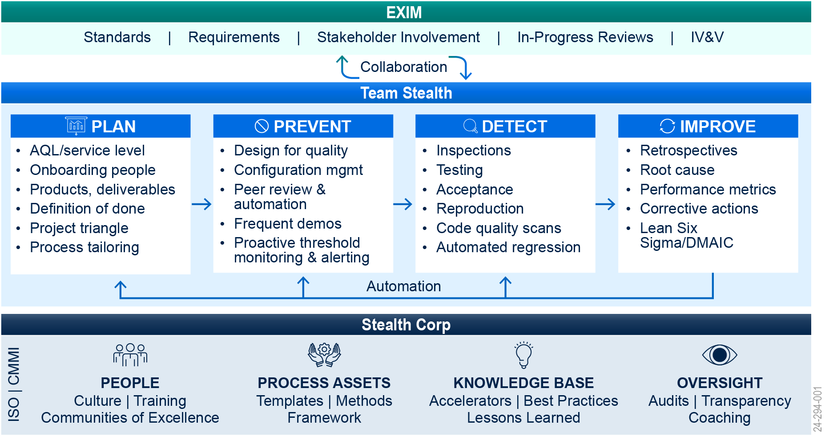

Figure 3. Stealth Quality Assurance Methodology reduces risks and improves execution by ensuring quality throughout the project lifecycle.

**The four phases above illustrate that quality is a continuous activity, not a one-time activity.** The phases are:

* **Plan:** We begin by planning for quality and integrating it into each project activity. Our methods require quality coverage for functional as well as non-functional requirements for software performance, security, usability, Section 508/accessibility, and availability.
* **Prevent:** We utilize established practices in Incident, Problem, and Change management throughout the project to prevent and detect defects through our collection of quality checks.
* **Detect:** We audit our work to confirm that we follow proper control procedures, maintain required documentation, and provide accurate reports.
* **Improve:** Agile Teams implement improvements via Sprint and Release retrospectives, led by a Scrum Master. Additionally, we utilize surveys and informal instruments to gather feedback from all stakeholders.

The Team Stealth BA/Scrum Master, with support and guidance from our corporate PMO, follows an established procedure for reporting, escalating, and tracking non-compliance issues. This allows Team Stealth to resolve the issues before they pose a significant risk. For problems that need additional oversight or facilitation, the BA/Scrum Master escalates the issue to Team Stealth Executive Management as required. Team Stealth reporting procedures entail weekly meetings with the EXIM COR to review the project progress, risks, and issues and discuss corrective actions to ensure a satisfactory resolution.

## Methods Used for Identifying and Preventing Defects

Team Stealth regularly performs scheduled and unscheduled processes and product inspections which are tracked from project start to completion. These Team Stealth methods incorporate the following reviews and audits for the identification and prevention of application defects:

* **Deliverable Reviews:** Team Stealth inspects all deliverables and interim work products to ensure compliance with Acceptable Quality Levels (AQLs). Additionally, Team Stealth integrates a fully automated **Continuous Testing** process, as depicted in **Figure 4** below, into the System Development Life Cycle (SDLC) to ensure the delivered solution is of high quality.
* **Random Sampling:** Randomly select user support tickets to evaluate response times and resolutions.
* **Inspection:** Inspect the configurations and customizations in Salesforce to ensure they meet the specified business requirements.
* **Peer Reviews:** Conduct internal team peer and document assessment reviews. These reviews are especially useful when evaluating documents or deliverable content for accuracy and completeness.
* **Test Case Review:** Review the test cases and results to ensure adequate coverage and identification of issues.
* **Schedule Review:** Monitor release schedules and verify adherence to planned deployment dates and success of releases.
* **User Surveys:** Collect feedback from users post-training to assess satisfaction and effectiveness of the training sessions.
* **Process Reviews and Audits**: Conduct process reviews throughout the lifecycle to ensure the teams conduct all work in accordance with Team Stealth's best practices and, as appropriate, meet contractual requirements.
* **Quality Audits:** Team Stealth corporate Project Management Organization (PMO) conducts proactive reviews to identify problem and performance issues and establishes any needed course corrections.

Figure 4. Team Stealth continuous testing, when implemented diligently, results in flawless delivery of a high-quality solution.

## Roles and Responsibilities

* **EXIM Contracting Officer (CO)**: Oversees contract compliance.
* **EXIM Contracting Officer's Representative (COR)**: Monitors contractor performance and ensures quality.
* **EXIM Program Manager**: Conducts regular evaluations and reports on performance metrics.
* **Team Stealth Project Team**: Manages the day-to-day operations and ensures adherence to performance standards.

## Performance Requirements Summary (PRS)

The Performance Requirements Summary (PRS) specifies the key areas of performance, the standards for performance, and the acceptable quality levels (AQLs) that Team Stealth must achieve.

**Table 1** below illustrates example performance metrics from each key area of performance. For a comprehensive list of all performance metrics, please refer to the detailed metrics outlined for each objective and sub-objective within the Performance Work Statement (PWS) section above.

Table 1. Performance Metrics Examples from the Key Areas of Performance

|  |  |  |  |  |
| --- | --- | --- | --- | --- |
| **Performance Area** | **Performance Standard** | **AQL** | **Method of Surveillance** | **Frequency** |
| User Administration Support | Response time for support requests | 95% | Random sampling | Monthly |
| Security / ATO Activities | Timeliness and accuracy of documentation updates | 90% | Document review | Quarterly |
| Configuration and Development | Accuracy and completeness of configurations | 90% | Inspection | Each release |
| Quality Assurance Testing | Test coverage rate | 90% | Test case review | Each test phase |
| Release Management | Release schedule adherence and deployment success rate | 95% | Schedule review | Each release |
| Technical Documentation | Completeness and accuracy of documentation | 90% | Document review | Annually |
| User Guides and Training | User satisfaction with training | 80% | User surveys | After training sessions |
| Requirements Analysis | Requirements capture accuracy | 95% | Requirements review | Each sprint |

The table above provides a snapshot of the key metrics used to measure performance across various areas. The full set of performance metrics, which includes additional details and specific targets for each objective and sub-objective, can be found within the corresponding sections of the PWS. These metrics ensure that all aspects of the project are closely monitored and meet the high standards required by EXIM.

## Performance Metrics and Reports

* **Monthly Report**: Summarizes system health, ticket volume, work accomplished, user metrics, and planned work for the upcoming month.
* **Quarterly Report**: Details the updates to security documentation, vulnerabilities addressed, and compliance with security standards.
* **Release Retrospective Analysis**: Analyzes the success and challenges of each release, aiming at continuous improvement of the release process.
* **Training Feedback Report**: Evaluates the effectiveness of training sessions based on user feedback and identifies areas for improvement.

## Evaluation and Feedback

* Regular meetings between EXIM COR and Team Stealth to discuss performance, address issues, and implement improvements.
* Continuous feedback loop from EXIM stakeholders to ensure the services provided align with their expectations and requirements.
* Periodic reviews and updates to the QASP to reflect changes in project scope, objectives, and performance standards.

## Continuous Improvement

* **User Feedback Integration**: Regularly gather and incorporate user feedback into the service delivery process.
* **Review of New Features**: Continuously review new Salesforce features and potential AI implementations to enhance EXIM's Salesforce platform.
* **Innovation and Optimization Recommendations**: Provide ongoing recommendations for innovative solutions and optimizations to improve system efficiency and effectiveness.

## Conclusion

The QASP is essential for ensuring that Team Stealth's services meet EXIM's high standards. By following this plan, EXIM can ensure continuous improvement and successful implementation of Salesforce services and licenses. We are dedicated to meeting and exceeding the performance requirements outlined in the PWS and are confident in establishing a Quality Assurance Program that ensures acceptable quality levels for all EXIM deliverables

# Key Personnel Resumes with Commitment Letters

In Appendix A of this proposal, Team Stealth includes resumes with commitment letters for the following key personnel:

* Janani Ganesan, Scrum Master / Business Analyst;
* Nick Rampton, Senior Salesforce Developer; and
* Akeem Shane, Salesforce Developer.

# Staffing/ Transition Plan

## Staffing

Based on Team Stealth's experience, teams with shared goals consistently achieve success. We anticipate Team Stealth and EXIM working as a unified team to reach our common goals over the next five years. Below, we outline our organizational structure, key personnel, roles and responsibilities, talent acquisition process, and contractual support to ensure seamless execution and operations.

### Organization Chart

Team Stealth is committed to accomplishing strategic objectives set forth by EXIM, keeping in mind decades of experience working on similar Salesforce-related programs in other Federal agencies; we propose the below Org structure for an efficient working model between EXIM and Team Stealth.

**Figure 5** shows the organizational structure and reporting relationship to establish a robust governance framework for the project.

Figure 5. **Organization Chart**

Team Stealth leadership is fully committed to the success of this program. The project team will be supported by a larger pool of subject matter experts (Corporate Reach back) from the Salesforce practice team on an as-needed basis. This demonstrates Team Stealth's dedication to providing additional support for the success of EXIM's mission. After evaluating the overarching technical objectives, Team Stealth has handpicked the following three key personnel roles essential for this project:

* **Scrum Mpast aster/Business Analyst**  
  *Qualifications and Experience:* Certified Scrum Master and Business Analyst with significant experience in Agile project management and business analysis. Adept at facilitating Scrum ceremonies, managing project backlogs, and ensuring alignment between business objectives and technical execution. Proven ability to gather requirements, define user stories, and collaborate with cross-functional teams to deliver high-quality solutions. This role is key to ensuring agile and effective project delivery for EXIM.
* **Sr. Salesforce Developer***Qualifications and Experience:* Certified Salesforce Developer with significant experience developing custom Salesforce applications. Skilled in Apex, Visualforce, Lightning components, and integration with third-party systems. This developer will contribute to creating tailored solutions that meet EXIM’s specific requirements.
* **Salesforce Developer***Qualifications and Experience:* Certified Salesforce Developer with extensive experience in creating and customizing Salesforce applications. Proficient in Apex, Visualforce, Lightning development, and implementing complex business processes. This role supports the scalability and adaptability of EXIM’s Salesforce solutions.

Key Personnel from Team Stealth

The following key personnel from Team Stealth are handpicked to align with the EXIM RFQ requirements, ensuring effective and efficient project execution.

Scrum Master / Business Analyst: Janani Ganesan

**Relevance:** Janani Ganesan excels in Agile project management and business analysis. Her expertise in facilitating Scrum ceremonies, managing project backlogs, and aligning technical execution with business objectives will ensure the EXIM project adapts swiftly to changing requirements. Additionally, Janani has extensive experience with Salesforce implementation projects and is Salesforce certified.

**Certifications:**

* Certified as Platform App Builder
* Certified as Salesforce Administrator
* Project Management Professional (PMP)

**Responsibility:**

* **Agile Governance:** Facilitates iterative development and continuous improvement.
* **Requirement Analysis:** Gathering, documenting, and analyzing requirements for all salesforce enhancements and projects
* **User guides and training:** Create, update, and maintain user guides to support different user groups.

Sr. Salesforce Developer: Nick Rampton

**Relevance:** Nick Rampton brings deep technical expertise in developing complex Salesforce solutions. His experience on multiple projects, for numerous clients, in both Sr. Developer and Technical Lead roles, ensures that enhancements and new developments are implemented effectively, addressing both existing and new requirements.

**Certification:**

* Salesforce Platform Developer I
* Salesforce OmniStudio Developer

**Responsibility:**

* **Enhancements and New Developments:** Implements critical system enhancements.
* **Quality Assurance:** provide testing support to new enhancements.
* **Technical Support:** Provides expert technical guidance and support to User administration, ATO, and release management.

Salesforce Developer: Akeem Shane

**Relevance:** Akeem Shane specializes in creating and customizing Salesforce applications. His skills are vital for developing tailored solutions that meet EXIM’s specific requirements.

**Certifications:**

* Salesforce Certified Administrator
* Salesforce Certified Platform Developer I
* Salesforce Certified Platform Developer II

**Responsibility:**

* **Enhancements and New Developments:** Develop custom Salesforce applications.
* **Operations and Maintenance:** Maintains smooth platform functionality.
* **Quality Assurance:** Ensures new developments meet EXIM’s standards.

While Team Stealth considers these three roles essential for success, we have a clear understanding of the roles and responsibilities for all positions based on the overarching technical objectives outlined in the Statement of Objectives, the proposed PWS, and the QASP. **Figure 6** below depicts that.

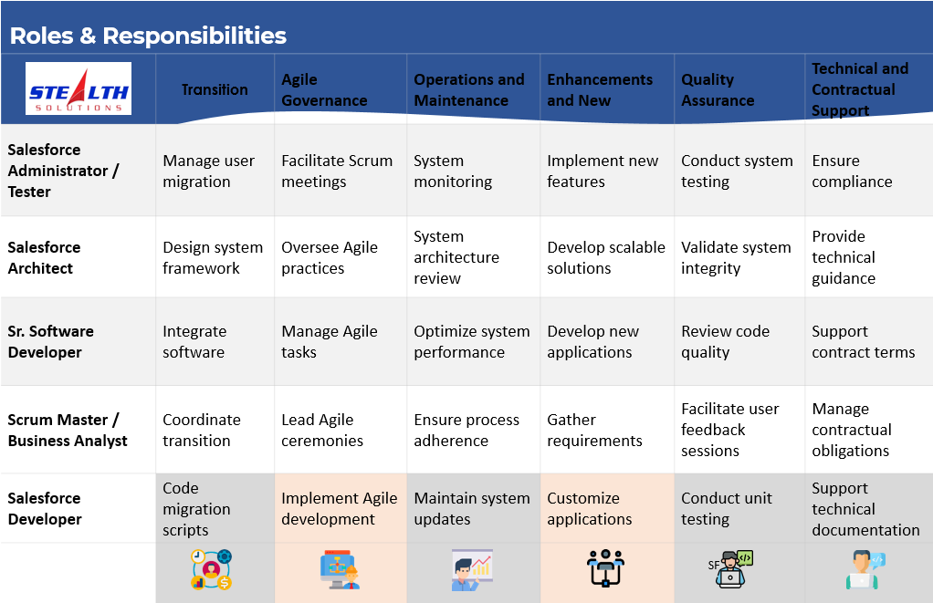

Figure 6. Role & Responsibilities

As Team Stealth works on execution, it will be supported by a robust Talent Acquisition & PMO team. Below, we briefly outline our proactive Talent acquisition and PMO processes that Team Stealth uses to ensure seamless execution and operations.

**Talent Acquisition**: Team Stealth employs a comprehensive screening and selection process to ensure we hire the best talent. Our recruitment strategy includes leveraging an extensive network of industry professionals and utilizing proactive recruitment techniques to quickly meet project demands. This ensures we can effectively support EXIM's Salesforce implementation and ongoing operational needs.

**Contingency Planning**: We maintain a robust contingency plan to manage personnel acquisition, ensuring continuity and minimal disruption in project delivery. This includes a pool of pre-vetted candidates ready to step in as needed, providing EXIM with assurance of uninterrupted service and expertise.

Ability to Ramp Up and Meet PWS Requirements

* **Efficient Onboarding**: Our streamlined onboarding processes ensure new hires are quickly integrated and productive. We provide comprehensive training and support to ensure that new team members are fully equipped to meet project requirements for EXIM.
* **Scalable Resources**: We maintain access to a broad talent pool, allowing us to scale resources up or down as project needs evolve. This flexibility ensures that we can respond quickly to changes in project scope or requirements, a crucial factor for EXIM's dynamic project needs.
* **Proactive Resource Management**: Regular capacity planning and resource allocation ensure optimal team composition and workload distribution. Our resource management practices enable us to maintain high levels of productivity and efficiency, ensuring EXIM’s project deadlines and quality standards are consistently met.
* **Contractual Support**: Our dedicated contractual support team ensures compliance with contract terms and conditions, manages documentation, and addresses any contractual issues promptly. We are well-versed in federal contracting regulations and practices, ensuring smooth contractual engagements for EXIM.

Team Stealth is committed to delivering robust, scalable, and compliant technology solutions that cater to EXIM’s unique needs. Our extensive experience, strategic approach, and proven track record position us as the ideal partner for EXIM’s Salesforce implementation project. The alignment of Team Stealth’s key personnel with EXIM project requirements ensures comprehensive management across all facets. Their expertise in Salesforce implementation, Agile practices, and technical support will drive the project's success, meeting and exceeding EXIM’s expectations for operational efficiency, strategic value, and continuous improvement.

## Transition Plan

Team Stealth will initiate the transition from the existing contractor with a comprehensive and structured approach to ensure a seamless handover and continuity of the Salesforce implementation for EXIM. Our transition plan will cover the following critical activities for a successful Transition-In:

1. **Knowledge and Documentation Acquisition**:

* Understand EXIM’s current business processes (“As-Is” state) supported by the incumbent systems.
* Acquire technical and functional specifications of the incumbent systems.
* Gather support-related activities and documentation.
* Identify key stakeholders within the system user community.

1. **Support and Operations Continuity**:

* Collaborate with incumbent staff to ensure uninterrupted system support and operations.
* Work with incumbent staff to enhance system documentation.
* Assume full system support responsibilities from the incumbent.

Our transition plan will clearly define the scope, detailed schedule, success factors, associated risks, dependencies, stakeholder communication plan, R.A.C.I. matrix, and incumbent exit criteria.

**Key Activities**:

1. **Detailed Assessment and Knowledge Transfer**:

* Conduct meetings and workshops with the outgoing contractor to understand the current system, ongoing projects, configurations, customizations, and any existing issues or pending tasks.
* Gather relevant documentation, including design documents, configuration workbooks, user manuals, and other artifacts that provide insights into the system’s architecture and functionalities.

1. **Review and Audit**:

* Perform a thorough review and audit of the existing Salesforce environment, validating configurations, customizations, and integrations to ensure they align with EXIM’s requirements and best practices.
* Assess the system for potential risks or areas of improvement, documenting the current state and identifying gaps or issues to be addressed during the transition.

1. **Communication and Coordination**:

* Establish clear communication channels with EXIM stakeholders to provide regular updates on the transition progress and address any concerns promptly.

1. **Transition Timeline Development**:

* Develop a detailed transition timeline with key milestones, resource allocation, and risk mitigation strategies.
* Ensure minimal disruption to ongoing operations by working closely with EXIM throughout the transition.

1. **Management and Optimization**:

* Take over the management of the Salesforce environment, ensuring all configurations and customizations are maintained and optimized.

By following this structured transition plan, Team Stealth ensures a smooth and efficient handover, setting the stage for continued success and enhancements in EXIM’s Salesforce implementation. Throughout the transition process, Team Stealth staff will exercise high patience and professionalism to ensure a successful and smooth transition.

# Technical Approach to Successfully Meeting Deliverables

This section begins with an overview of our overarching approach to meeting EXIM objectives, followed by a detailed explanation of Team Stealth's approach to specific work areas and tasks.

## Approach for meeting objectives/focus area

Team Stealth has extensive Salesforce expertise, ensuring the seamless execution of all project requirements outlined by EXIM. We have a proven track record of successfully implementing and enhancing Salesforce solutions for diverse clients, leveraging industry best practices and advanced tools. We excel in deploying CI/CD practices to streamline development operations while maintaining stringent security and compliance standards. With our comprehensive understanding of EXIM's objectives and a commitment to continuous improvement, we are well-equipped to deliver a highly efficient and user-centric Salesforce platform that aligns with EXIM's strategic goals and business needs. The section below describes how Team Stealth will meet the EXIM objectives at a high level.

**Focus Area 1 - Enhancing Current Business Development (BD) Processes:** Team Stealth plans to comprehensively improve EXIM’s BD processes by first extending the scope of user feedback beyond initial interviews. By including cross-functional teams and establishing ongoing feedback channels, such as regular surveys and a dedicated portal, the approach ensures a broader and continuous collection of insights. This feedback will inform the prioritization of targeted system enhancements, ensuring that the most impactful changes are implemented first, with a phased rollout allowing for iterative testing and feedback.

In terms of workflow optimization, Team Stealth intends to leverage process mining tools to deeply analyze and visualize existing workflows, thereby identifying and automating not only redundancies but also less obvious inefficiencies. This will be complemented by the integration of dynamic workflow automation tools that adjust to changing business rules without manual intervention.

Advanced technologies, including AI-driven lead scoring and predictive analytics for customer behavior, will be utilized to refine lead management and personalize follow-up strategies. Additionally, the integration of third-party applications, such as business card scanning and meeting booking tools, will streamline data entry and scheduling, while custom APIs will ensure robust integration and data consistency.

To uphold data integrity, advanced algorithms for duplicate detection and data cleansing will automate these processes, supported by a newly established data governance framework. This framework will set clear standards and responsibilities for data management across the organization.

Finally, the effectiveness of these enhancements will be continuously monitored through real-time dashboards that track key performance indicators (KPIs). A dedicated continuous improvement team will review this performance data, gather user feedback, and make ongoing adjustments, ensuring that the BD processes not only meet current needs but are also adaptable to future changes.

**Focus Area 2 - Improving Reporting and Expanding CRM Analytics:** To optimize EXIM’s reporting and analytics capabilities within the Salesforce ecosystem, Team Stealth proposes the following technical approach:

* **Comprehensive Data Analytics Review:** Conduct a thorough assessment of EXIM's current Salesforce CRM utilization to pinpoint gaps and define critical Key Performance Indicators (KPIs) that align with strategic objectives. Engage directly with business unit leaders to capture and integrate specific reporting needs.
* **Dynamic Dashboard Implementation:** Utilize Salesforce’s Lightning Dashboard and Report Builder to create tailored, real-time dashboards. These dashboards will focus on visualizing metrics related to customer engagement, sales performance, and operational efficiency, facilitating instantaneous managerial decision-making.
* **Advanced Predictive Analytics:** Integrate Salesforce Einstein Analytics to harness AI-driven insights, enhancing predictive capabilities across customer data. Develop sophisticated forecasting models to anticipate market trends, customer needs, and potential sales opportunities.
* **Automated Reporting Solutions:** Establish automated workflows using Salesforce Process Builder and Scheduled Flow to generate and disseminate reports on a predefined schedule. Implement the Salesforce Alert System to provide real-time notifications for anomalies or significant KPI deviations.
* **Comprehensive Salesforce Integration:** Seamlessly integrate additional data sources into Salesforce, such as EXIM’s Participant Hub, EXIM Online, Loan Management System (ELMS), and the Reporting System (ERS). Utilize Salesforce’s MuleSoft for robust API connections that ensure data consistency and security across platforms.
* **Iterative Feedback Loop:** Initiate regular Sprint Review sessions with stakeholders to gather feedback on the reporting tools’ effectiveness and usability. Employ Agile methodologies to iteratively refine and enhance the Salesforce CRM analytics functionalities based on user feedback and emerging business requirements.

Team Stealth will also conduct regular feedback sessions with EXIM users to continuously refine and enhance reporting capabilities, ensuring they evolve with EXIM’s changing needs.

**Focus Area 3 -Integration with Other EXIM Applications:** To optimize EXIM's integration of Salesforce with key systems like the EXIM Participant Hub, EXIM Online, ELMS, and ERS, Team Stealth proposes an advanced technical approach centered around Salesforce and MuleSoft integration platforms:

1. **Integration Architecture Development:**

* Design a scalable, API-led architecture using MuleSoft’s Anypoint Platform to ensure seamless and secure data synchronization between Salesforce and other EXIM systems.
* Employ Salesforce Connect for real-time integration and MuleSoft for complex transactional connections, ensuring robust, bidirectional data flows.

1. **API Strategy and Management:**

* Develop RESTful APIs for dynamic data interactions and SOAP for secure transactions, managed via MuleSoft’s Anypoint Platform for full lifecycle API management.
* Implement comprehensive API security policies including OAuth 2.0 and JWT to protect data integrity and confidentiality.

1. **Data Mapping and Transformation:**

* Conduct precise data mapping and utilize MuleSoft DataWeave for advanced data transformation, aligning disparate data structures across systems into a cohesive model within Salesforce.

1. **Salesforce Customization and Process Automation:**

* Customize Salesforce with specific objects and fields to mirror integrated data structures, enhancing visibility and access for EXIM staff.
* Automate routine workflows and data updates within Salesforce using Process Builder and Flow to minimize manual entry and increase operational efficiency.

1. **Data Quality and User Interface Enhancements:**

* Integrate data quality tools within Salesforce to perform continuous cleansing and deduplication, ensuring high data accuracy.
* Revamp the Salesforce UI to provide intuitive, unified views of comprehensive customer data, significantly enhancing user experience.

1. **Advanced Reporting and Analytics:**

* Leverage Salesforce Reports, Dashboards, and Einstein Analytics to deliver real-time insights into customer journeys and lifecycle metrics, facilitating data-driven decision-making.

This consolidated approach ensures robust integration and leverages cutting-edge technologies to provide EXIM staff with a seamless, efficient, and enriched user experience while maintaining high standards of data security and quality**.**

**Focus Area 4 - Expand Salesforce to New Teams:** Team Stealth's refined strategy for expanding Salesforce to new EXIM teams, including Global Business Development, China and Transformational Exports, and non-business development units like the Office of Contracting Services, emphasizes a streamlined and efficient onboarding process:

1. **Custom Needs Assessment:** Conduct in-depth assessments with each team to tailor Salesforce configurations to their unique operational needs, enhancing workflows and data management.
2. **Structured Implementation Planning:** Develop concise implementation plans with clear milestones, resource allocations, and timelines. Adjust plans based on feedback during the implementation phase.
3. **Salesforce Customization and Integration:** Customize and configure Salesforce to support specific team processes, ensuring seamless data sharing and access control adjustments between new and existing teams.
4. **Pilot Testing and Data Migration:** Implement pilot testing with key users to refine system setups and migrate legacy data securely into Salesforce, maintaining data integrity.
5. **Comprehensive Training and Support:** Deliver targeted training through workshops, digital guides, and e-learning, followed by robust post-launch support to ensure smooth transition and continuous improvement.
6. **Full Deployment and Monitoring:** Roll out the fully tested Salesforce system to all new teams, monitor its usage, and iterate based on user feedback to optimize platform efficiency.

This approach ensures a seamless expansion of Salesforce across EXIM, driving better integration and operational efficiency across diverse teams.

**Focus Area 5 - Developer Operations Enhancements**: Team Stealth has always adopted the CI/CD process in all our Salesforce implementations. We will implement CI/CD and perform other developer operations enhancements by:

* Conducting a thorough assessment of the current development processes, tools, and practices to identify areas for improvement.
* Developing a detailed implementation plan that includes timelines, milestones, and resources required for the transition to a CI/CD model.
* Selecting appropriate CI/CD tools that integrate well with Salesforce, such as Salesforce DX, Git, Jenkins, and Bitbucket.
* Setting up automated build and deployment pipelines that allow developers to commit code changes, run automated tests, and deploy to staging environments seamlessly.
* Implementing automated testing frameworks to ensure code quality and functionality. This includes unit tests, integration tests, and end-to-end tests.
* Setting up and maintaining multiple Salesforce environments (development, testing, staging, production) to support the CI/CD process.
* Implementing security best practices in the CI/CD pipeline, including automated security scans, static code analysis, and regular security audits.
* Ensuring compliance with EXIM and government-wide guidelines, such as data protection and privacy regulations, by incorporating compliance checks into the CI/CD process.
* Reviewing and updating regularly the CI/CD processes and tools to incorporate new features, technologies, and best practices.

**Figure 7** below shows the CI/CD process that will be implemented for EXIM to ensure developer operations are improved and the highest standards are maintained for all releases.

Figure 7. EXIM's CI/CD model to accelerate deployment cycles and enhance security and compliance

**Focus Area 6 - Continuous Improvement**: Team Stealth is dedicated to enhancing EXIM's CRM program through a dynamic approach to continuous improvement, focusing on both technical development and user experience:

1. **Feedback Mechanisms:**

* Implement robust systems using Salesforce’s built-in tools to collect ongoing feedback from users and stakeholders, integrating this directly into the development cycle through a prioritized product backlog.

1. **Data-Driven Enhancement:**

* Utilize Salesforce CRM Analytics and other tools to continuously monitor user behavior and system effectiveness, identifying opportunities for improvement and ensuring decisions are guided by actionable data.

1. **Feature Updates and AI Integration:**

* Regularly review Salesforce updates to identify and implement new features that align with EXIM’s strategic goals, particularly those involving advanced AI capabilities, planning these rollouts to minimize operational disruption.

1. **Continuous Learning:**

* Support EXIM’s adaptation to system enhancements with tailored training and responsive support, fostering an organizational culture of continuous learning and adaptation.

1. **Strategic Review:**

* Conduct periodic reviews to ensure CRM enhancements remain aligned with broader organizational objectives and leverage emerging technologies effectively.

This streamlined approach ensures EXIM’s CRM system is not only responsive to user needs and industry trends but is also proactively enhanced to leverage technological advancements like AI, enhancing overall efficiency and user satisfaction.

Team Stealth completely understands that continuous improvement of the system and BD processes is essential for EXIM to run an efficient organization. Team Stealth always focuses on continuous improvement for all our clients by:

* Implementing mechanisms to gather feedback from users and stakeholders on an ongoing basis.
* Utilizing Salesforce’s built-in feedback tools to collect and analyze user feedback directly within the platform.
* For all feedback gathered, creating and including a work product in the product backlog and the development is planned based on the priority
* Using Salesforce CRM Analytics and other analytical tools to gain insights into system usage, user behavior, and process effectiveness.
* Planning and implementing new features and updates in a structured manner, ensuring minimal disruption to ongoing operations.

## Technical Approach for Scope of Work and the Corresponding Deliverables

In this section, we will describe the technical approach for meeting each of the EXIM technical objectives and sub-objectives:

#### Objective Area 1: Salesforce Product Licenses (SOO Section 4.1)

Team Stealth's approach to managing Salesforce Product Licenses for EXIM encompasses meticulous oversight of license types, quantities, and user engagement levels. Our process includes:

1. **Continuous Monitoring:**

* We will conduct ongoing monitoring of all subscribed Salesforce licenses to ensure optimal utilization and prevent either underutilization or potential overages that could lead to unexpected costs.

1. **Usage Threshold Notifications:**

* Proactively track and report license usage, notifying EXIM when license occupancy reaches critical thresholds of 80%, 90%, and 100%. This systematic alert system enables timely decision-making regarding the need for additional licenses or adjustments in usage to avoid unnecessary expenditure.

1. **Customizable Reporting:**

* Upon contract award, we will collaborate with EXIM to tailor our notification and reporting protocols to meet specific organizational needs and preferences. This includes setting custom alert thresholds and reporting frequencies to align with EXIM's operational requirements and budget cycles.

1. **Strategic License Management:**

* Provide strategic insights into license management, assisting EXIM in planning for future needs based on trends and usage patterns. This will include recommendations for scaling up or scaling down license allocations in a cost-effective manner, ensuring that EXIM always has access to the necessary Salesforce functionalities without overspending.

This enhanced management approach not only ensures efficient license utilization but also supports EXIM’s broader strategic goals by optimizing Salesforce investments and adapting to changing organizational needs.

#### Objective Area 2: Licenses for Products on AppExchange (SOO Section 4.2)

Similar to Objective Area 1 above, Team Stealth will perform similar oversight and notification to EXIM.

#### Objective Area 3: Salesforce Implementation and Support Services (SOO Section 4.3)

Team Stealth is dedicated to providing comprehensive Salesforce implementation and support services to EXIM, ensuring both a seamless transition and continuous optimization of the Salesforce platform. Our approach begins with an in-depth needs assessment, engaging directly with EXIM stakeholders through workshops and interviews to tailor Salesforce precisely to their specific requirements, business processes, and strategic goals. We will customize Salesforce by configuring objects, fields, workflows, and automation to streamline business processes, enhance data handling, and improve user experience.

Our strategy prioritizes stringent security measures, including role-based access controls, data encryption, and audit trails to meet EXIM's regulatory requirements. We will integrate Salesforce seamlessly with essential EXIM systems such as the Participant Hub, EXIM Online, and ELMS, providing a unified view of customer interactions. Comprehensive training for users and administrators will ensure proficiency and maximize system utility, enhancing productivity and user satisfaction.

Post-implementation, Team Stealth will offer ongoing support and enhancements, including regular system monitoring, performance tuning, and proactive troubleshooting. We will manage and test major Salesforce updates to ensure smooth integration, continually aligning the platform with EXIM's evolving business needs. Through these efforts, Team Stealth aims to help EXIM maximize the value of its Salesforce investment and achieve its business goals.

#### Objective Area 3.1: User Administration Support (SOO Section 4.3.1)

Team Stealth is committed to enhancing EXIM’s user administration and support through a technically advanced and integrated approach that streamlines user management and improves system security and user responsiveness.

Our strategy involves deploying automated tools for efficient user account management, handling everything from account creation to deactivation for 90-120 internal users and 50 external users. We will implement role-based access controls within Salesforce to manage and audit access levels appropriately, ensuring security and compliance with organizational policies.

To address user support and troubleshooting, we will establish a dedicated support desk integrated with Salesforce, adhering to ITIL best practices for incident management. This desk will be supported by self-service password reset tools and assistance for login issues to minimize user downtime. System monitoring tools will be deployed to proactively detect and resolve access issues and security breaches, with regular updates and patches scheduled to maintain system integrity.

For ticket management, Jira will be utilized to streamline the creation and routing of support tickets. Each ticket will be automatically categorized and routed to the appropriate team based on predefined rules, ensuring efficient resolution. Jira workflows will automate notifications, escalations, and follow-ups, enhancing the traceability and accountability of the support process.

Training sessions tailored to new features and system updates will be regularly conducted, complemented by digital manuals and FAQs to assist users in resolving common issues independently. A feedback system within Jira will gather user insights to continuously improve the service.

By integrating these elements, Team Stealth aims to provide a robust support system that not only resolves issues promptly but also continuously adapts to meet the evolving needs of EXIM’s workforce, thereby enhancing overall productivity and user satisfaction.

Figure 8. Engagement Model for GMS Users

#### Objective Area 3.2: Security / ATO Activities (SOO Section 4.3.2)

Team Stealth is committed to bolstering the security framework and ensuring continuous Authorization to Operate (ATO) compliance for EXIM’s Salesforce environment. This initiative, in collaboration with EXIM's Program Manager and Cybersecurity team, focuses on rigorous system documentation, security implementations, and robust monitoring practices, aligned with federal standards. The following activities will be supported:

* **System Documentation and Regulatory Compliance**: We will meticulously update and maintain critical security documents, including system architecture diagrams, Privacy Impact Assessments, System Security Plans, and configuration documentation. These efforts support both the acquisition and ongoing maintenance of the ATO. Regular compliance reviews with the Cybersecurity team will ensure all system updates and documentation align with federal security regulations.
* **Advanced Security Measures and Auditing:** Our approach includes deploying state-of-the-art access control systems within Salesforce to manage data access effectively. We'll leverage automated monitoring tools for real-time threat detection and response, ensuring that security protocols are promptly updated to counter emerging threats. Comprehensive system audits, both scheduled and ad-hoc, will evaluate the integrity and effectiveness of security practices, while impact analyses for new projects will preemptively address potential security risks.
* **Proactive Training and System Awareness:** Security training sessions will be tailored to various user roles, emphasizing responsible data handling, threat recognition, and the importance of security measures. Regular awareness campaigns will reinforce the significance of security and encourage a proactive security culture across all departments.
* **Continuous Improvement and Strategic Reporting:** Detailed security reports and regular updates will be provided to EXIM’s Cybersecurity team, offering insights into security status, audit outcomes, and any incidents of non-compliance or breaches. A feedback mechanism will be integral, enabling continuous refinement of security measures based on operational feedback and evolving security landscapes.

Through these enhanced technical strategies, Team Stealth aims to not only secure EXIM’s Salesforce platform but also to foster an environment of continuous security improvement, aligning with EXIM’s operational needs and federal security mandates.

#### Objective Area 3.3: Requirements Analysis / Solution Design (SOO Section 4.3.3)

Team Stealth will commence the requirements analysis phase for EXIM by engaging in comprehensive discovery sessions with key stakeholders, including business leaders, end-users, and IT personnel. These sessions will help us gather detailed information on EXIM’s current processes, pain points, and strategic objectives. Using techniques such as interviews, surveys, and workshops, we will collect both functional and non-functional requirements. The collected requirements will be meticulously documented and mapped in a Requirements Traceability Matrix (RTM), which will serve as a living document to ensure all requirements are addressed throughout the project lifecycle. The RTM will facilitate tracking the progress and fulfillment of each requirement, ensuring nothing is overlooked during development.

To capture the specific needs of users, Team Stealth will develop detailed user stories that describe the desired functionality from the end-user perspective. Each user story will include acceptance criteria to define the conditions for successful implementation. These stories will be prioritized based on business value and complexity, ensuring that the most critical features are delivered first. User stories will be reviewed and validated with EXIM stakeholders to confirm their accuracy and relevance. This iterative process will allow for adjustments and refinements, ensuring that the final solution aligns perfectly with user expectations and business goals.

In parallel with gathering requirements, Team Stealth will create a Logical Data Model (LDM) that outlines the structure of the data to be managed within Salesforce. The LDM will detail the entities, attributes, and relationships, providing a clear blueprint for data management and integration. This model will be crucial in designing a database schema that supports EXIM’s data needs, ensuring data integrity, consistency, and scalability. The LDM will be reviewed and refined in collaboration with EXIM’s data management team to ensure it meets all organizational and regulatory requirements.

Based on the user stories and logical data model, Team Stealth will develop comprehensive design documents that describe the technical solution in detail. These documents will include system architecture diagrams, detailed specifications for customizations, integration plans, and user interface designs. The design documents will also outline the configuration of Salesforce features such as workflows, validation rules, and security settings. By providing a detailed roadmap for implementation, the design documents will guide the development team in building a robust and scalable solution. Regular design review sessions with EXIM stakeholders will ensure that the solution aligns with business requirements and technical standards, paving the way for successful implementation.

#### Objective Area 3.4: Configuration and Development (SOO Section 4.3.4)

Team Stealth starts with configuration of Salesforce’s out-of-the-box features to align with EXIM’s business processes. This includes setting up custom objects, fields, page layouts, and record types to accurately reflect EXIM’s data structure and user interface requirements. Workflow rules, validation rules, and process automation will be configured to streamline business operations, reduce manual effort, and enhance data accuracy. Our team will ensure that all configurations adhere to best practices, maintaining a balance between customization and maintainability.

In parallel with configuration, Team Stealth will develop custom functionalities that cannot be achieved through standard configuration. This includes developing Apex classes, triggers, Lightning components, and Visualforce pages to extend Salesforce’s capabilities. Our developers will follow a structured development process, starting with detailed design and coding, followed by rigorous testing in sandbox environments. Each piece of custom development will be thoroughly documented and reviewed to ensure it meets the specified requirements and integrates seamlessly with existing configurations. By adopting an iterative development approach, we will incorporate feedback and adjust to ensure the final solution meets EXIM’s expectations and business needs.

To manage and track all configuration and development activities, Team Stealth will utilize a Configuration Management Plan (CMP) document. The CMP will outline the processes and tools for managing changes to the Salesforce platform, ensuring all configurations and customizations are systematically controlled and documented. This plan will include version control procedures, detailing how changes are recorded, reviewed, and approved before implementation. The CMP will also specify the use of a centralized repository for storing configuration files and development artifacts, enabling effective collaboration among team members. Regular audits and reviews will be conducted to ensure compliance with the CMP, maintaining the integrity and consistency of the Salesforce environment. By adhering to the CMP, Team Stealth will ensure a structured and organized approach to configuration and development, minimizing risks and ensuring high-quality outcomes for EXIM.

#### Objective Area 3.5: Quality Assurance Testing (SOO Section 4.3.5)

Team Stealth will implement a rigorous Quality Assurance (QA) testing process to ensure the new Salesforce platform developments for EXIM meets the highest standards of performance, functionality, and reliability. Our QA process begins with the creation of a comprehensive Test Plan, which outlines the scope, objectives, resources, schedule, and methodologies for testing. This document will serve as a roadmap for all testing activities and ensure that every aspect of the system is thoroughly evaluated. The Test Plan will be complemented by Test Cases, which provide detailed, step-by-step instructions for verifying each feature and functionality against the requirements specified in the Requirements Traceability Matrix (RTM).

We conduct multiple types of testing to cover all aspects of the system. Unit testing will be performed by developers to ensure that individual components function correctly. This will be followed by integration testing to verify that different modules work together seamlessly. System testing will assess the end-to-end functionality of the entire system, ensuring that it meets the business requirements and specifications. User Acceptance Testing (UAT) will involve EXIM stakeholders and end-users to validate that the system performs as expected in real-world scenarios. During UAT, detailed feedback will be collected, and any issues or discrepancies will be documented in Defect Reports.

To support these testing activities, several key documents will be prepared and utilized. The Test Cases document will provide the basis for executing tests and recording results, ensuring that each requirement is validated thoroughly. A Traceability Matrix will be maintained to map test cases to requirements, ensuring complete coverage and traceability throughout the testing process. Defect Reports will document any issues identified during testing, including steps to reproduce, severity, and status. These reports will be tracked in a Defect Management System, enabling the team to prioritize and address issues promptly.

Upon completion of testing, a Test Summary Report will be prepared, summarizing the testing activities, results, and any remaining issues. This report will provide a clear overview of the system’s quality and readiness for deployment. The QA process will also include a final review and sign-off from EXIM stakeholders, confirming that the system meets all requirements and is ready for production. By implementing a structured and thorough QA process, Team Stealth will ensure that the Salesforce platform delivered to EXIM is robust, reliable, and capable of supporting their business objectives effectively.

#### Objective Area 3.6: Release Management (SOO Section 4.3.6)

Team Stealth will streamline EXIM’s Salesforce release management process, ensuring regular and efficient updates every two weeks while minimizing operational disruption. Our technical approach to release management includes:

* **Strategic Release Planning**: Collaborate closely with EXIM's Program Manager to meticulously plan each release. This includes selecting relevant user stories, scheduling enhancements, and securing all necessary pre-deployment approvals. We will focus on structuring the release contents to align with EXIM's operational priorities and timeframes.
* **Efficient Deployment Process**: Implement structured deployment protocols to ensure smooth rollouts of Salesforce updates. Releases are primarily scheduled for Thursday evenings from 8:00 p.m. to 10:00 p.m. Eastern Time, optimizing timing to reduce impact on both East and West Coast users. Flexibility in scheduling will be maintained to accommodate releases with larger scopes or necessary integrations on other evenings or weekends.
* **Rigorous Testing and Verification**: Conduct thorough pre-deployment testing to verify the functionality and integration of new features. Post-deployment verification testing will be executed in collaboration with the Program Manager and relevant stakeholders to ensure that all updates function as intended in the live environment.
* **Continuous Improvement**: Incorporate feedback from each release cycle to refine and enhance the release management process. This continuous improvement will ensure that the release strategy remains effective and responsive to EXIM’s evolving needs.

By adhering to this approach, Team Stealth aims to provide EXIM with a robust, predictable, and efficient release management service that supports continuous improvement and operational excellence in its Salesforce environment.

Environment Management:

The section below describes the efficient environment management strategy implemented by Team Stealth to have seamless release management.

The project will use various environments throughout the project lifecycle to support development, testing, and deployment. **Table 2** below includes the list of project environments, purpose, frequency, and the location for where the environment is stored/detailed.

Table 2. Team Stealth Environments

|  |  |  |  |
| --- | --- | --- | --- |
| Environment | Type of Sandbox | Purpose | Duration of Use |
| Development (DEV) | Developer Sandbox | Major and minor releases, code development, unit tests  Multiple instances | The development team has access throughout the implementation |
| Integration (INT) | Developer Sandbox | Functional, integration, and performance testing; compliance testing | The development team has access throughout the implementation |
| TEST  (QA) | Developer Sandbox | Functional, integration, and performance testing; Accessibility compliance; and browser compatibility and security tests | The development team has access throughout the implementation |
| User Acceptance Testing (UAT) | Partial Copy Sandbox | User acceptance tests and **training** purposes This could also be used for staging purposes. | Available during UAT periods |
| Staging | Full Copy | Pre-production performance testing and preparation | Available post-UAT |
| Production (with Failover) | N/A | Production environment integration and reporting | Available at Go-Live |
| Break-fix | Partial Copy Sandbox | Production issues debug & hotfix validation environment | Available post-Go-Live |

**Figure 9** below shows how the Sandbox environments are connected.

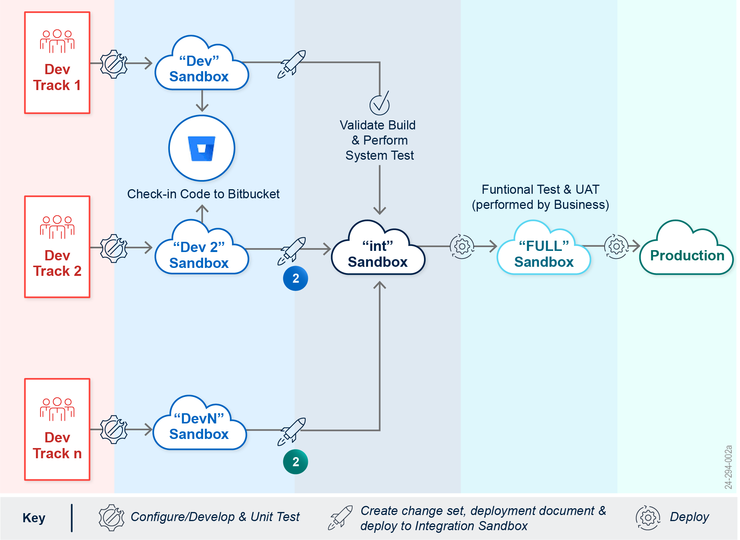

Figure 9. Multiple Sandbox Environments and Code Promotion Flow for EXIM Implementation Project

Benefits of the Environment Strategy

The systematic use of multiple environments ensures that at every stage of the development lifecycle, there is a dedicated space to perform specific tests and validations, reducing the risk of introducing errors into the production environment. This methodical approach not only enhances the security and stability of the Salesforce platform but also allows for continuous improvement and efficient handling of new features and bug fixes. Each environment serves a critical role in maintaining the health and efficacy of the development process, ultimately leading to a more reliable and user-friendly product for EXIM.

#### Objective Area 3.7: Technical Documentation

Team Stealth is dedicated to delivering comprehensive technical documentation services for EXIM, emphasizing system resilience, security compliance, and effective knowledge transfer. Our meticulously designed approach, outlined below, encompasses all aspects of documentation essential for system security, disaster recovery, and continuous system maintenance.

**1. Documentation Development and Maintenance:**

* We rigorously update, create, and maintain all required technical documentation to support EXIM’s operational and security needs. This includes detailed documentation for system architecture, configuration, and specific processes related to security and Authorization to Operate (ATO) compliance.
* Our documentation will also include clear instructions and protocols for disaster recovery, ensuring that the system can be quickly rebuilt and restored in case of any major incidents. This is crucial for maintaining continuity of operations and minimizing downtime.

**2. Clarity and Detail in Configuration Documentation:**

* To aid in onboarding and training future EXIM staff or contractors, our documentation will provide clear and detailed descriptions of how Salesforce is configured and the rationale behind these configurations. This will include diagrams, workflow descriptions, and configuration settings, all designed to make the system as transparent and understandable as possible.
* Each piece of documentation will be crafted to ensure it is user-friendly and accessible, accommodating varying levels of technical expertise among EXIM staff and contractors.

**3. Regular Reviews and Updates:**

* All technical documentation will be subject to regular reviews and updates to ensure it remains accurate and relevant as the Salesforce platform evolves. This involves periodic auditing of the documentation in line with system updates, new security protocols, or changes in compliance requirements.
* We will also implement a feedback system to gather inputs from users and technical staff, using this feedback to continually improve the quality and usefulness of the documentation.

By adhering to this structured approach, Team Stealth ensures that EXIM’s technical documentation is robust, up-to-date, and aligned with both operational requirements and compliance mandates. This documentation strategy not only supports the current system management and security needs but also prepares EXIM for future scalability and staff transitions, ensuring long-term system resilience and efficiency.

#### Object Area 3.8: User Guides and User Training

Team Stealth will provide a comprehensive suite of user guides and training programs to support EXIM’s diverse user groups, ensuring all personnel are well-versed in the functionalities of their Salesforce environment. Our approach focuses on both the creation of targeted instructional materials and the delivery of effective training sessions.

* **User Guides and Documentation:** We create, update, and maintain a range of user guides and tutorials tailored to different user needs. This includes detailed guides for new features and processes, as well as general user manuals that serve both as training material for new users and reference material for existing staff. Our documentation strategy ensures that every piece of content is clear, informative, and accessible, aiding users in navigating and utilizing the Salesforce platform efficiently.
* **Training and Development:** In collaboration with EXIM’s Program Manager and key business stakeholders, we will develop and implement a structured training regimen. This involves assessing the training needs for each new feature or enhancement and designing appropriate training sessions that could include live workshops, webinars, and interactive e-learning modules. Our training programs will be designed to be flexible, catering to the different learning paces and styles of EXIM’s staff.
* **Salesforce In-App Guidance**: Recognizing the potential of Salesforce’s In-App Guidance, we plan to implement these tools extensively within EXIM’s Salesforce environment. These in-app prompts and walkthroughs will be customized to guide users through new features and complex processes directly within their workflow. This real-time assistance is designed to enhance user understanding and foster a more intuitive user experience.
* **Continuous Improvement:** Our approach also includes a feedback loop from users to continually refine and enhance the user guides, training, and in-app support tools. By monitoring user interactions and soliciting feedback, we can identify areas for improvement, ensuring the training materials and guides evolve in line with user needs and Salesforce platform updates.
* **Delivering Training:** Team Stealth will deliver ongoing training based on the EXIM’s training plan and timeline, including specific types of user training:
  + End User Training (Internal);
  + End User Training (External);
  + Administrator Training; and
  + Refresher Training.

We plan to conduct training sessions around each planned release. Team Stealth will conduct training on the modules and functionalities implemented during the release.

Table 3. Training Plan Matrix

|  |  |  |
| --- | --- | --- |
| Type of Training | Delivery Method | Training Focus |
| End User Training – Internal | Delivered in Person and Online | Focus on new releases, new applications and newly onboarded internal users. |
| End User Training – External | Delivered Online and Recorded Webinars | Focus on external users and new functionality released. |
| Administrator Training | Delivered In Person and Online | For EXIM Internal Power Users |
| Refresher Training | Delivered Online | Conducted Regularly as a refresher course to all users. |

By implementing this integrated approach to user documentation and training, Team Stealth aims to ensure that all EXIM staff, regardless of their role or previous Salesforce experience, are equipped with the knowledge and tools needed to maximize their efficiency and effectiveness on the platform.

#### Objective Area 3.9: Salesforce Releases

Team Stealth will manage Salesforce's major releases for EXIM, including Winter, Spring, and Summer updates, using a structured and systematic approach to ensure seamless transitions and leverage new features and improvements effectively.

When Salesforce releases the notes for an upcoming update, Team Stealth will thoroughly review the notes to understand the new features, enhancements, deprecated functionalities, and critical updates. This initial review is followed by an impact assessment to determine how the new release will affect EXIM's existing customizations, integrations, workflows, and processes. Team Stealth will create a comprehensive release strategy, define the release calendar, and ensure all stakeholders are aware of the schedule and their roles in the process.

When the planning phase is complete, the focus shifts to testing and validation. Sandbox environments will be set up and refreshed to mirror the production environment accurately, allowing for thorough testing. Based on the release dates mentioned by Salesforce, the new features will be turned on in the Sandbox environment and thoroughly tested. We will also perform a detailed risk assessment of the new features/changes being released.

As the deployment date approaches, training sessions for users and administrators are conducted, using a mix of live workshops, webinars, and e-learning modules, to help familiarize them with new features and changes.

On the day of deployment, a final review meeting with all stakeholders will confirm readiness, ensuring all identified issues have been resolved or mitigated. The deployment will be executed following a detailed plan, ideally during off-peak hours to minimize disruption. This comprehensive approach ensures EXIM can effectively manage Salesforce's major releases, maintaining a robust and efficient Salesforce implementation aligned with its business objectives and user needs.

## Project Management Plan (PMP)

Upon award, Team Stealth will work with the EXIM COR to understand if a complete, formal Project Management Plan (PMP) should be developed that outlines all specific EXIM COR defined requirements, project timeline of deliverables and expected completion dates, deliverables, and timeline to detail and meet the EXIM’s specific requirements as defined in the SOO. As stated in the solicitation we understand that the PMP will require separate approval to secure an optional price from Team Stealth. We do provide an outline of what we typically provide in a PMP in Appendix B – Sample Project Management Plan Table of Contents. The development and oversight of a PMP will require the assignment and services of a Team Stealth PM, which is currently not included in the EXIM pricing document.

## Contract Management Communication

In full compliance with the solicitation, Team Stealth is responsible for total contractor management during the performance of this contract; the administration of the contract also requires maximum coordination between EXIM and Team Stealth.

Team Stealth provides open and ongoing communication access between the EXIM CO/COR and our assigned representative; Raj Shekhar, [raj.shelhar@stealth-us.com](mailto:raj.shelhar@stealth-us.com), (206) 495-7898. Mr. Shekhar will provide and keep the list of Team Stealth personnel always updated with the assigned EXIM CO/COR to ensure our project team has access to the appropriate EXIM personnel.

We understand that all contract administration shall be affected by the CO. Communications pertaining to the contract administration shall be addressed directly to the CO. No changes to the performance work statement are authorized without a written modification to the contract executed by the CO. If at any time Team Stealth believes any person other than the CO has given direction that changes the performance work statement, Team Stealth will immediately inform the Contracting Officer Representative (COR) and CO by the most expeditious means.

The EXIM Contracting Officer Representative (COR) monitors all technical aspects of the contract and assists in contract administration. The COR is Team Stealth’s primary point of contact. Key COR functions are monitoring the delivery of technical requirements by Team Stealth, performing inspections necessary in connection with contract performance, maintaining written and oral communications with Team Stealth concerning technical aspects of the award, monitoring Team Stealth’s performance, and notifying both the CO and contractor of any deficiencies.

The two key Contract Management deliverables are:

* **Monthly Status Reports (MSR) –** Team Stealth will provide an MSR electronically to the EXIM program/project office required by the award and/or orders (as applicable) and the Contracting Officer Representative (COR) no later than the 15th calendar day of each subsequent month. This report shall summarize the activities performed by the Team Stealth in support of this contract; specifically, the report shall outline tasks accomplished, meetings attended problems encountered, mitigation strategies, risks, and any other relevant performance information.
* **Interim Project Reviews –** Team Stealth will provide Interim Project Reviews (IPR) quarterly to EXIM and the COR. IPRs will be used to manage and report on project schedules, budgets, risks, and invoices.

A key element of an effective overall communication plan also contains the actions of communication to key EXIM stakeholders, internal and external, as well as any new users of the Salesforce applications that will be enhanced or developed for this new contract. EXIM has a history of deploying Salesforce-based CRM services with involvement from executive boards and processes for information delivery and training on new functionality. Team Stealth suggests that we work within the guidelines that have been established for the smooth implementation of new functionality deployed by Team Stealth. We will take our lead from the COR/EXIM PM and provide all solicited recommendations for changes or improvements and implement accordingly.

## Subcontractor Management

Stealth Solutions (Stealth), as the prime contractor for EXIM, is committed to upholding the highest standards of management, performance, and oversight for all engaged subcontractors, including REI Systems (REI), to ensure alignment with EXIM's expectations and requirements. Our approach is structured to proactively manage and enhance subcontractor performance through rigorous monitoring, transparent communication, and swift corrective actions when necessary.

**Stealth Subcontractor Management and Monitoring Approach:**

**1. Subcontractor Integration and Oversight:**

* **Contractual Alignment:** Team Stealth will ensure that all subcontracting agreements explicitly define performance metrics, deliverables, and timelines that align with EXIM’s primary contract specifications. This includes integrating clear clauses for accountability and repercussions in cases of non-compliance or subpar performance.
* **Regular Monitoring:** Implement a systematic monitoring plan that includes frequent status checks, performance reviews, and compliance audits to assess the effectiveness and efficiency of subcontractor contributions. This monitoring will be supported by tools and technologies that provide real-time data on subcontractor activities.

**2. Performance Management:**

* **Performance Benchmarks:** Set clear, quantifiable performance benchmarks based on the contract’s objectives. REI, as a subcontractor, will be required to meet or exceed these benchmarks to maintain alignment with EXIM’s overall project goals.
* **Regular Performance Reviews:** Conduct regular performance evaluations of REI's contributions to identify any potential or existing issues with their outputs. These evaluations will involve both quantitative assessments and qualitative feedback from relevant stakeholders.

**3. Corrective Action and Continuous Improvement:**

* **Immediate Corrective Measures:** In cases where REI’s performance is identified as less than satisfactory, Team Stealth will promptly intervene to implement corrective actions. This could involve additional training, reallocating resources, or revising strategies to realign the subcontractor’s outputs with project requirements.
* **Continuous Feedback Loop:** Establish a continuous feedback mechanism that allows for ongoing communication between Team Stealth, REI, and EXIM stakeholders. This will facilitate the rapid addressing of any concerns and support the dynamic adjustment of strategies to meet evolving project needs.

**4. Reporting and Transparency:**

* **Transparent Reporting:** Ensure all activities and performance metrics are transparently reported to EXIM. This includes detailed reports on REI’s performance, the actions taken to address any deficiencies, and the outcomes of those actions.
* **Stakeholder Engagement:** Keep EXIM continuously informed of all subcontractor management activities, reinforcing Team Stealth’s commitment to transparency and accountability.

**5. CPARS Performance Impact:**

* **CPARS Awareness and Strategy:** Recognize the potential impact of subcontractor performance on Team Stealth’s performance evaluation within the Contractor Performance Assessment Reporting System (CPARS). Proactively manage subcontractor activities to uphold high ratings and address any factors that could negatively impact the evaluation.

By implementing this comprehensive management approach, Team Stealth ensures that all subcontractor activities, specifically those of REI, are aligned with the contractual obligations and expectations of EXIM. This proactive and structured management strategy is designed to optimize overall project outcomes while maintaining high standards of performance and accountability.

## Agile – Scrum Development Software Development Lifecycle

Team Stealth’s Agile philosophy and practices detail the standardization in software development to promote quick response to changing environments, changes in user requirements, and accelerated project deadlines. The project uses the Agile Scrum methodology shown in **Figure 10**. Based on the gathered requirements, Team Stealth will build a detailed product backlog in JIRA. The backlog will be prioritized based on EXIM Stakeholder inputs. Team Stealth will ensure that all items in the backlog address one or more of the focus areas and objectives. The prioritized backlog will be implemented in either 2-week or 3-week sprints. The sprints will be planned such that EXIM stakeholders are delivered business value at the end of every sprint.

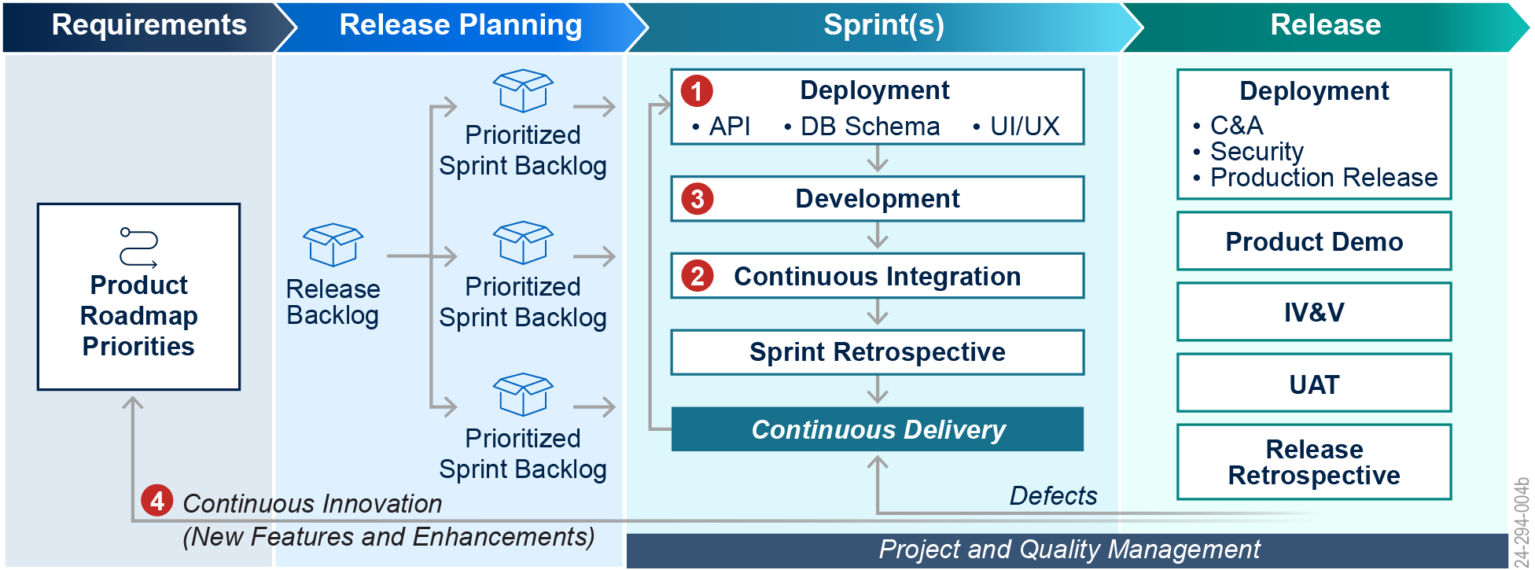

Figure 10. Agile-Scrum Lifecycle

The orange circled numbers show how (1) design is incorporated in active development; (3) developers work to meet user story acceptance criteria in each sprint; (2) code is continuously integrated and tested to achieve a 100% working and releasable product; and (4) a feedback loop of product innovation and enhancements is executed with each release to inform the product roadmap priorities.

During each sprint, EXIM stakeholders will be presented with a demo of the items currently in development. This allows for immediate feedback which can be incorporated before the final release. At the sprint's conclusion, approved items will be launched into production according to the pre-established release plan. Additionally, Team Stealth will conduct a sprint retrospective at the end of each sprint to identify and address areas for improvement, emphasizing Agile’s commitment to continuous enhancement with every sprint cycle.

Appendices

Appendix A–Resumes and Letters of Commitment

On the following pages, Team Stealth includes resumes and letters of commitment for the following key staff:

* Janani Ganesan, Scrum Master / Business Analyst;
* Nick Rampton, Senior Salesforce Developer; and
* Akeem Shane, Salesforce Developer.

Janani Ganesan, PMP

Scrum Master / Business Analyst

Experience overview

Dynamic Senior Salesforce Consultant with IT experience in various stages of the software development life cycle including Project Management, Requirements Gathering & Analysis, Impact & Gap Analysis, Design, Development and Testing of Software applications. Salesforce Certified Administrator and Platform App Builder with more than 8 years of experience in Salesforce Project Management, Project Planning, Requirements gathering, Business Analysis, Implementation and Data migration. Experience in implementing projects from scratch in Sales, Service, Experience, Public Sector Solutions and Financial Cloud applications. Dedicated leader with experience in leading cross functional teams and consultants. PMP Certified.

Education

Bachelor of Information Technology(B.Tech)

Anna University

Technical Domain AnD FUNCTIONAL Expertise

Leadership | Problem Solving | Process Improvement | Agile Methodologies | Stakeholder Engagement | Project Management Methodologies | Negotiation | Team Management

certifications and Technology–Specific training

* Certified as Platform App Builder
* Certified as Salesforce Administrator
* Project Management Professional (PMP)

Project Experience

Stealth Solutions, VA November 2023 - Present

*Lead Salesforce Consultant*

*USAID Recruiting Application Implementation*

Key responsibilities include:

* Lead Salesforce Public Sector Solutions Grants Management Implementation project for the client.
* Lead and manage the Salesforce team, providing guidance and training.
* Taking Ownership of functional issues by identifying underlying problems, analyzing potential solutions.
* Provide direction for the team to achieve business department objectives while meeting security requirements.
* Perform configurations and manage release processes.
* Conduct Requirements Gathering session and Sprint Ceremonies with the Client.
* Build an effective communication process for system users and stakeholders.
* Ensure data integrity and security within Salesforce, adhering to FedRAMP standards.
* Provide effective solution for application business process that utilizes Omni Studio.
* Work on Integration plan consisting of Google Drive, ServiceNow, AIDnet SSO and digital signature tool with Salesforce.

American College of Radiology. Reston, VA September 2019 – October 2023

*Sr. Salesforce Business Analyst/Administrator*

Key responsibilities include:

* Liaise with business stakeholders and revenue strategy operations to maintain relationships between the technical and non-technical teams interacting with Salesforce.
* Plan roadmap and initiatives for Salesforce implementation with a budget of $6 million and 20,000 plus external customers for 500 employee company.
* Perform Configurations in Salesforce platform.
* Create and document iterative and Agile frameworks for cross-functional teams including product management, marketing, and member services.
* Supervise and lead a team of Salesforce Business Analysts and Developers.
* Manage user roles and permissions for 500 internal staff users.
* Act as thought leader and Solution Architect for Salesforce solutions to ensure quality and best practice designs.
* Aided in the integration of third-party software with Salesforce improving data consistency across CRM and marketing platforms.

The Athene Group, Herndon, VA July 2018 - September 2019

*Senior Salesforce Functional Lead, Mutual of America, Financial Services Industry*

Key responsibilities include:

* Gathered requirements from the Clients and documenting user stories in the agile accelerator.
* Provided solutions to business problems and working with Salesforce Architect and Developers.
* Created documentation on process flows, Project requirements, business architecture diagrams and functional design specifications.
* Deploy using DevOps tools like Visual Studio Code.
* Managed the client Sales cloud org dealing with lead lifecycle, opportunity, contact management, etc. to capture more leads and accelerate productivity from 45% to 87%.
* Led configuration and Creating Lightning flows, validation rules, profiles, workflows, process builders, reports, and dashboards, etc. in Salesforce Financial Cloud.
* Conducted /Led Design and Demo sessions with Clients.
* Configured and worked on getting requirements for customizations for CLM (Contract life cycle management) Package.

PCORI (Patient Centered Outcomes Research Institute),

Washington D.C. March 2017 - June 2018

*Senior Salesforce Consultant, Non-Profit Healthcare*

Key responsibilities include:

* Gathered requirements from stakeholders across the organization and document user stories in JIRA.
* Worked on implementing Pipeline Award Program Office project.
* Worked on implementing the self-service portal for Research Related Conference Awards which enables individuals to submit their proposal and view the decision online.
* Crafted the right solutions to solve complex business problems and assisting a team of developers with best practices.
* Worked with QA team to identify any gaps in development per requirements.
* Demoed to the business users after solution is implemented.
* Created documentation on process flows, Project requirements, use case specifications, and various technical processes.
* Created functional-specific documentation, user manual, and diagrammatic representation /flowcharts.
* Training of users and getting involved in the entire end-to-end functionality of the project based on Agile /Scrum Methodology.
* Led configuration in salesforce org which includes building and creating validation rules profiles, workflows, roles, sharing rules, reports, and Dashboards.

Phase One Consulting Group, Alexandria, VA January 2015 - February 2017

*Salesforce Consultant, Small business Administration (SBA)-Federal Government*

Key responsibilities include:

* Developed the Salesforce Community landing page for Military Veterans to register themselves for various classes.
* Worked with the business team and stakeholders in Agile /Scrum Methodology for the deliverables in sprints.
* Managed Salesforce Sales and Service cloud org including campaigns, contact management, and opportunity management.
* Handled all configuration and customizations inside salesforce for business owners.
* Designed Workflow Rules, Email alerts, Approval Processes, Validation Rules, profiles, and Salesforce Community.

NTT Data, CSX Technology, Jacksonville, FL December 2009 - July 2014

*Team Lead, Transportation*

Key responsibilities include:

* Implemented the validation rules on the objects and tabs, Page Layout, and Custom tab components to the needs of the application based on the Sales cloud.
* Formulated and configured case routing logic, assignment rules, and escalation and workflows to handle customer requests.

Configured /customized the salesforce applications as per the client’s requirement.

Customized objects like Objects, Fields, accounts, Contact, Lead, Opportunity, and Campaign.

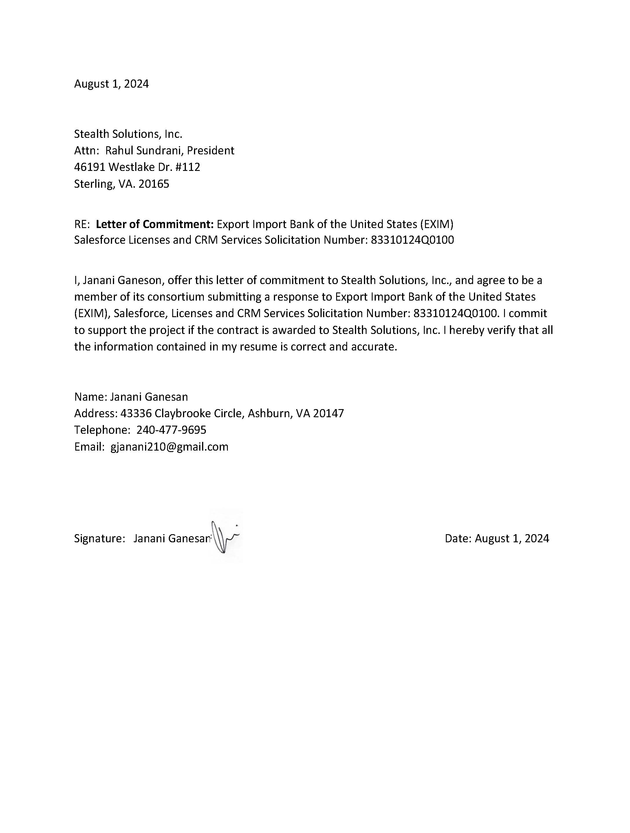

Nick Rampton

Senior Salesforce Developer

Experience overview

Mr. Nick Rampton has more than 6 years’ experience in Salesforce development, including application and managed package development, external systems integration, and data migrations on top of Apex and Visualforce coding. His work involves extensive requirements gathering and clarification, technical lead experience, user and administrator training, and documentation

Education

* MA in Slavic Languages and Literature, University of Wisconsin-Madison
* MA in Comparative Studies Brigham Young University, Provo, UT
* BA in Comparative Literature, Brigham Young University, Provo, UT

Technical Domain AnD FUNCTIONAL Expertise

* Salesforce: Apex, Apex triggers, Visualforce, SOQL, Single Sign-on, Email Services, Batch and Scheduled Apex, Custom Reports, Approval Processes, AWS Lambda integration with CloudWatch monitoring, Managed Package development and deployment
* Node.js, Angular, MongoDB, ES6, Python, Django, Flask, MySQL, SQLite, Java, Spring, HTML, CSS

certifications and Technology–Specific training

* Salesforce Platform Developer I certification
* Salesforce Omnistudio Developer certification

Project Experience

REI Systems, Sterling, Virginia April 2018–Present

*Senior Software Engineer*

Key responsibilities include:

* Extensive experience developing in Salesforce and the GovGrants platform, creating, maintaining, and enhancing GovGrants implementations
* Work focuses on improving application, negotiation, and monitoring processes for state and federal grants administered by various government agencies at the municipal, state, and federal levels
* Work includes development in an Agile environment addressing various phases of grant lifecycle
* Carrying out business analytic work, meeting with clients to clarify business requirements governed by federal legislation
* Experience coordinating the efforts of multi-developer teams to deliver complex enhancements to existing systems

Coding Dojo, Washington DC October 2017–February 2018

*Resident*

Key responsibilities include:

* Fourteen-week coding residency emphasizing full-stack development in an Agile setting, balancing individual drive with group progress
* Top-level certifications in MEAN, Java, Python, and algorithms and data structures

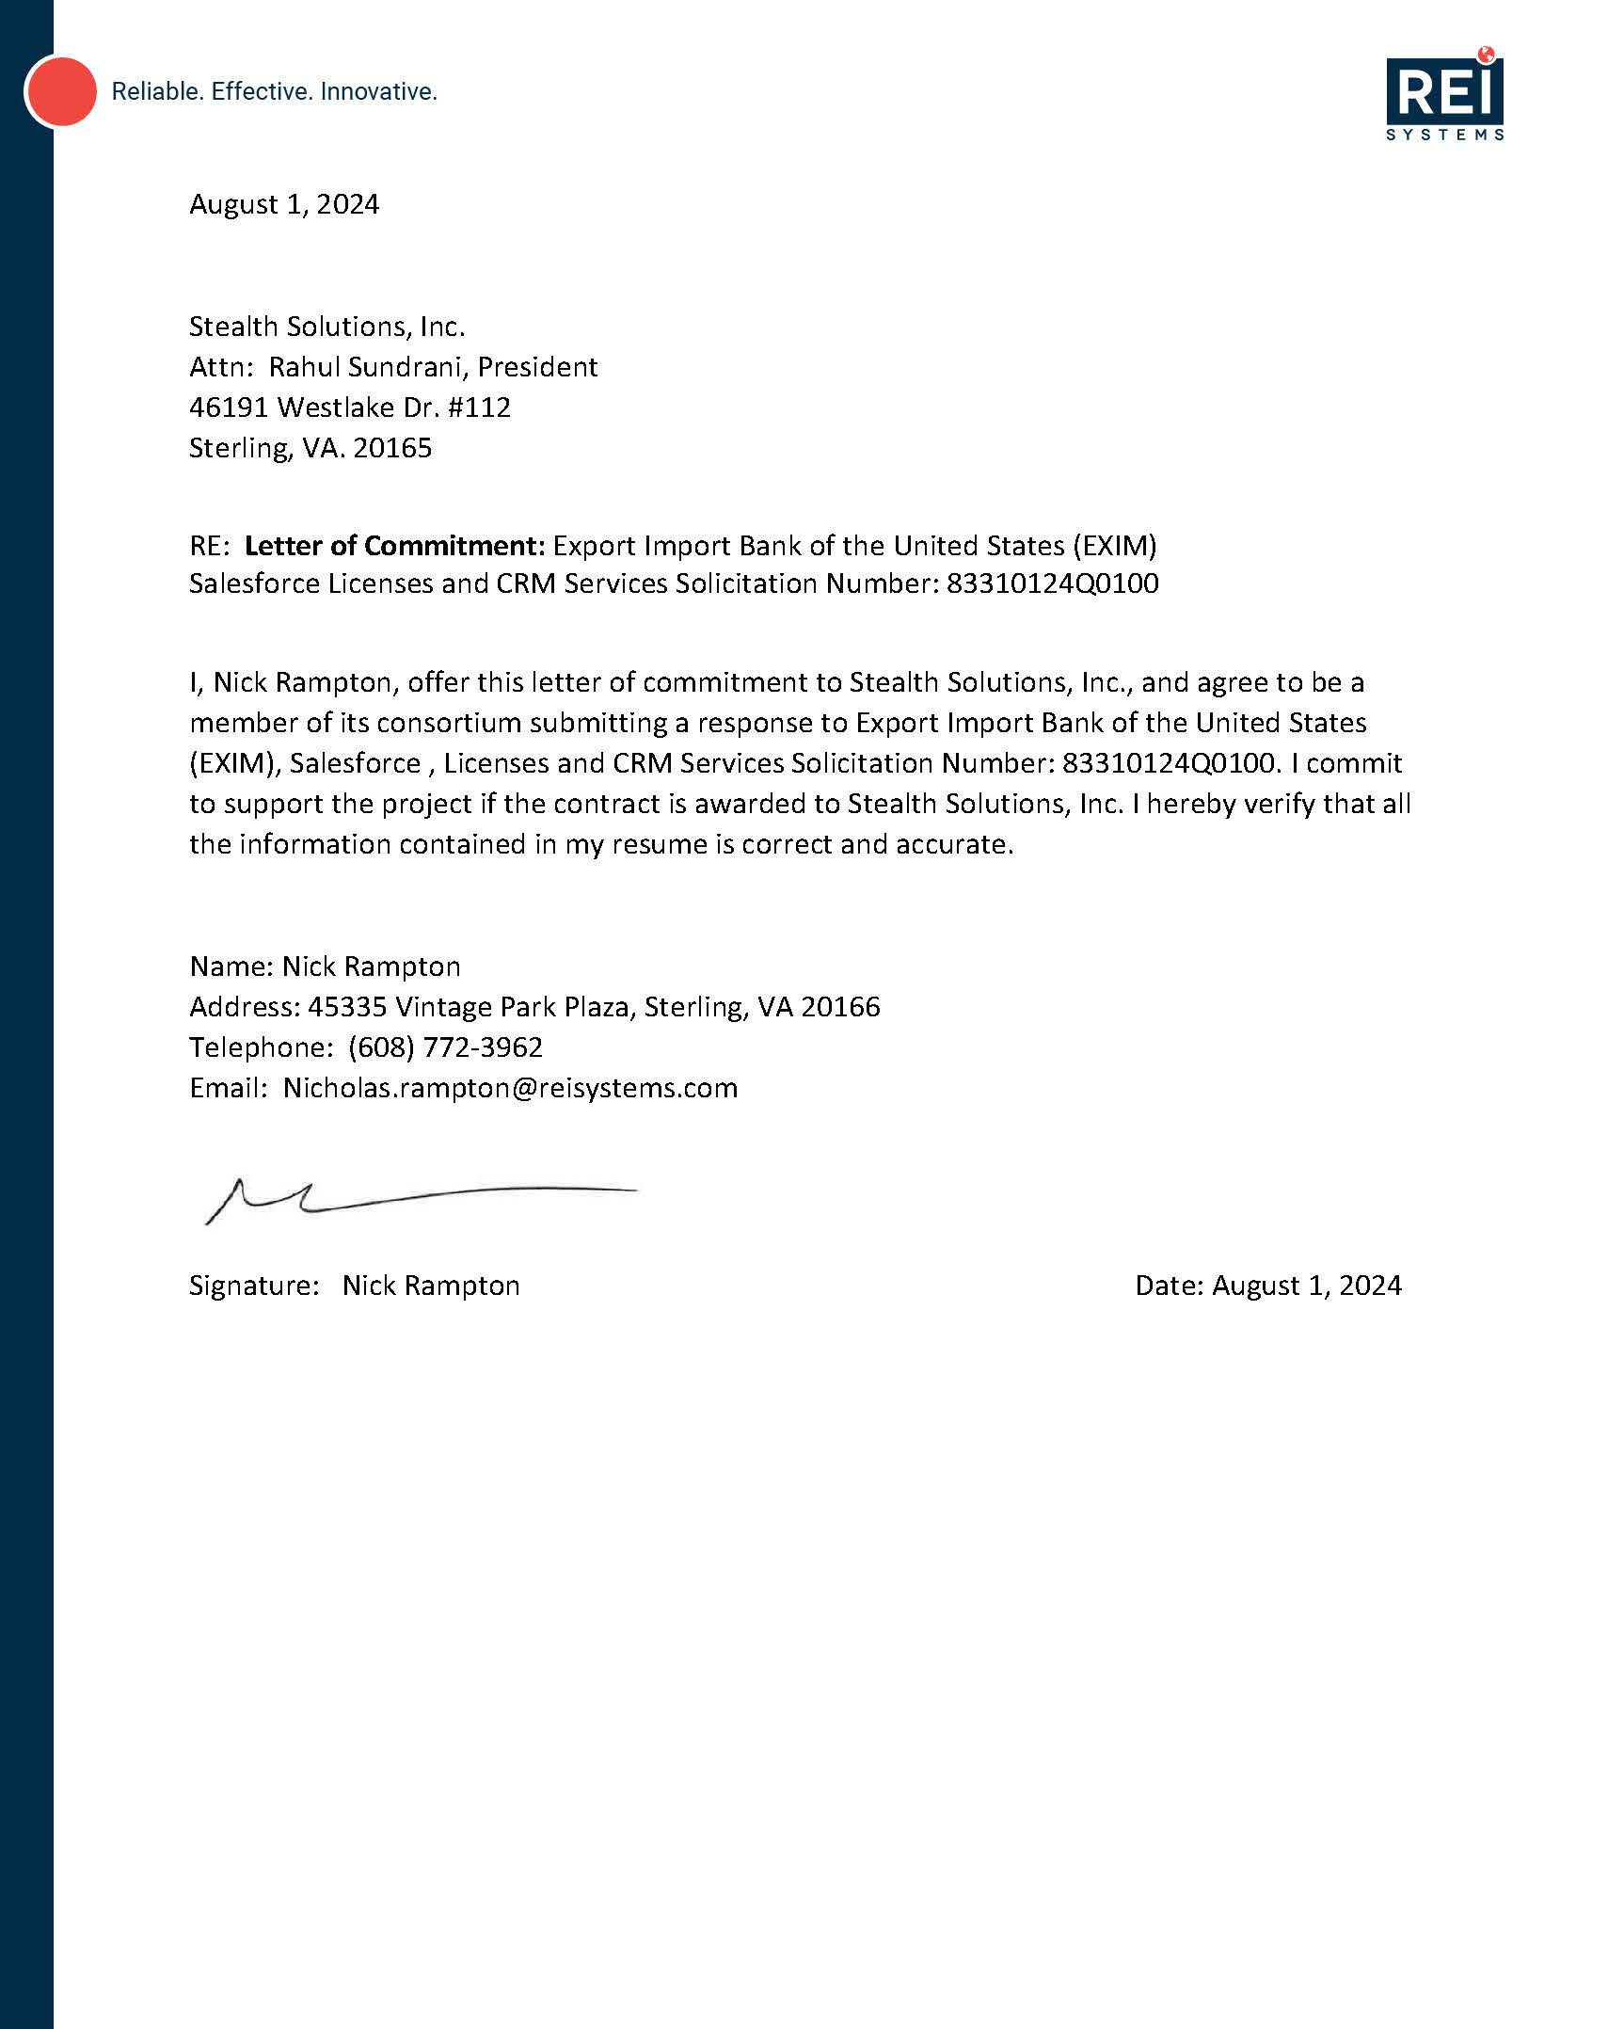

Akeem Shane

Salesforce Developer

Experience overview

An experienced Salesforce developer with four years of experience. Has an outstanding ability for problem-solving and critical thinking, as well as leadership qualities that allow me to demand the best from others and myself. Highly capable of building strong team cohesion which allows for an effective and timely accomplishment of any goal set forth.

Education

* University At Albany – SUNY, Bachelor of Science Albany, NY
* Double Major in Computer Science and Mathematics, 2019

Technical Domain AnD FUNCTIONAL Expertise

* Extensive programming experience with the Apex, SOQL, SOSL, Java, C, Python and SQL programming languages.
* Highly Proficient with HTML, CSS and JavaScript programming languages.
* Experienced with the C# programming language and the ASP.NET framework.
* Highly Proficient with the Agile Scrum Software Development Lifecycle methodology.
* Highly Proficient with GitHub and project management tools.
* Highly Proficient with Conga Composer Application.

certifications and Technology–Specific training

* Salesforce Certified Administrator
* Salesforce Certified Platform Developer I
* Salesforce Certified Platform Developer II

Project Experience

REI Systems LLC July 2020 - Present

*Salesforce Developer*

Key responsibilities include:

* Integrated third party Applications for documentation generation using an Application Programming Interface, which resulted in significantly reduced times in the overall end-users workflow.
* Designed and developed functionalities for a particular client while working for the implementation team as a software vendor, that were integrated into our overall product.
* Lead designed and developed large scale components in the system. Which because of their complexity due to being highly integrated with other parts of the system required tight knit teamwork between the Development and the Quality Assurance teams.

Apple, September 2019 – February 2020

*Technical Specialist*

Key responsibilities include:

* Give quick and efficient support to both new and current customers.
* Quickly assess the customer’s situation and be able to give either guidance or support in helping to resolve their situation.
* Provide personal training for the customer in basic operations of their Apple devices and Apple applications

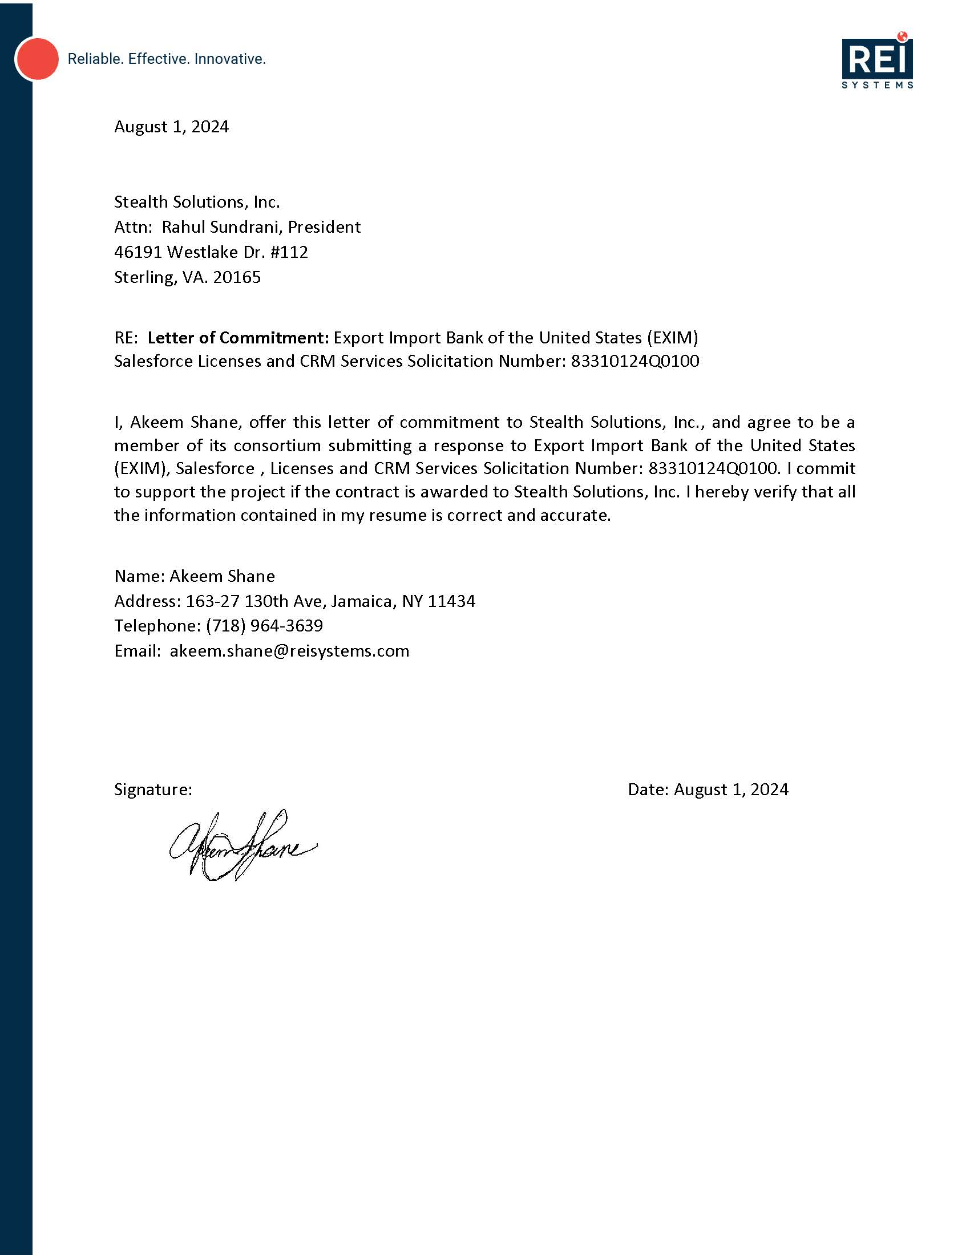

Appendix B–Sample Project Management Plan Table of Contents

Team Stealth is providing a sample Table of Contents from a Project Management Plan (PMP) developed for a previous project. Team Stealth will be pleased to provide a cost for the development of a PMP and have appropriate resources assigned upon approval from EXIM.

